Philosophy Department
Speaker Series 2012-2013
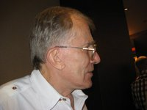
Welcomes:
Dr. Alphonso Lingis
Professor Emeritus of Philosophy, Pennsylvania State University
Topic: Truth in Reconciliation
Abstract
Discussion of the “Khmer Rouge” war crimes trial in Phom Penh (which I attended last year) and critical examination of the political and ethical issues involved.

November 23 @ 3:30 PM
MacKinnon Building, Room 306.
Everyone Welcome!
Refreshments following at Faculty Club.
Contact Dr. Karen Houle for more information: khoule@uoguelph.ca

