Welcome to the College of Arts!
The College of Arts is delighted to welcome Professor Troy Hourie to the School of English and Theatre Studies. Professor Hourie, a performance designer and inter-art installation artist comes to the UG with broad ranging expertise in design and performance. His visual art practice revolves, according to his website – and we love this – “themes of wonder, spectatorship, immersion, and intermediality.” The more wonder, the better!

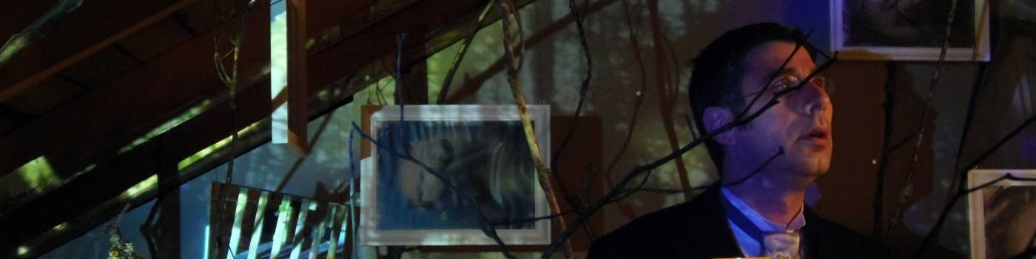

We are also thrilled to welcome Dr. Alyssa Woods to the School of Fine Art and Music. Dr. Woods comes to us from Carleton and is a researcher of popular music, specializing in issues of race, gender, and politics in hip-hop music and culture. She holds a PhD in Music Theory (2009) and a Graduate Certificate in Women’s Studies, both from the University of Michigan.
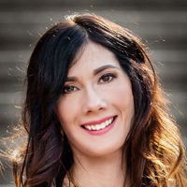

A warm welcome to an old friend. Welcome to Dr. John Walsh to the School of Languages and Literatures. From his activities with Classics students recreating the 480 BC Battle of Thermopylae on Johnston Green in 2017 to probing state of the art research websites synthesizing the world’s knowledge of ancient Greek, Dr. Walsh is a welcome addition to our distinguished faculty.
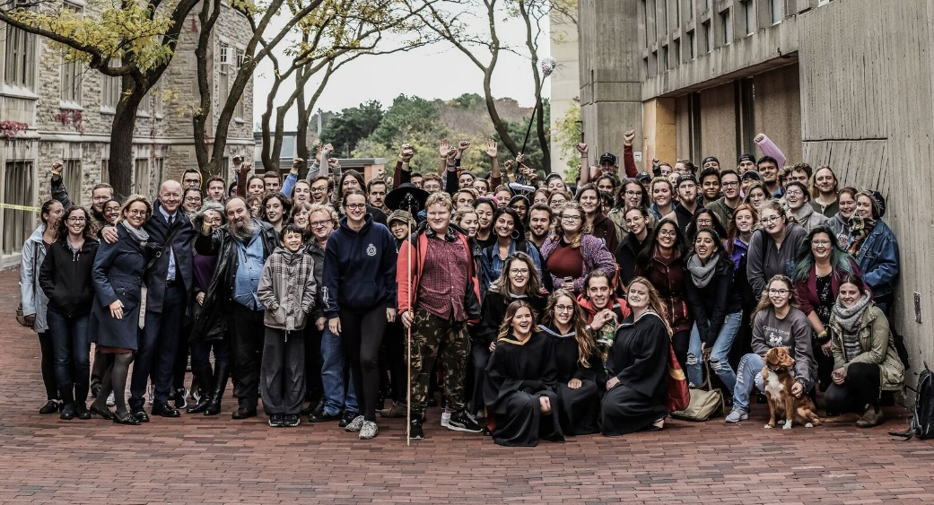

While he’s not new to the College, after about 730 days (but who’s counting?) as Acting Associate Dean, Academic, Dr. Ruediger Mueller has been confirmed as actual Associate Dean, Academic overseeing the BA Counseling Office, Bachelor of Arts and Science program, and all things curricular. Dr. Mueller was absconded from the School of Languages and Literatures where in his spare time he tackles the frightening prospect of German literature.
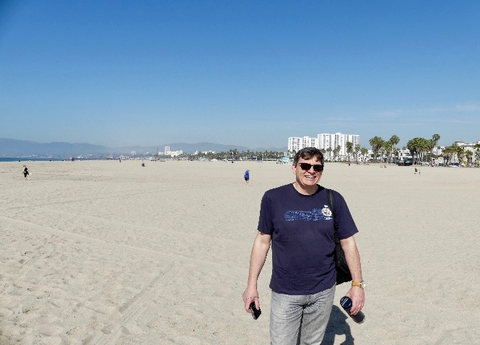

Finally, the College is so pleased to welcome Dr. Evren Altinkas from Turkey. Dr. Altinkas graduated from the International Relations Department of Dokuz Eylül University. He received postgraduate degrees from King’s College London in 2000 and Dokuz Eylül University in 2003 where he studied on the issue of Cyprus. He obtained his doctoral degree from Dokuz Eylül University in 2011 based on his dissertation comparing the development of the concept of intellectuals in Europe and in Turkey. Dr. Artinkas comes to Guelph via the Scholar at Risk program. We are happy to have him with us.
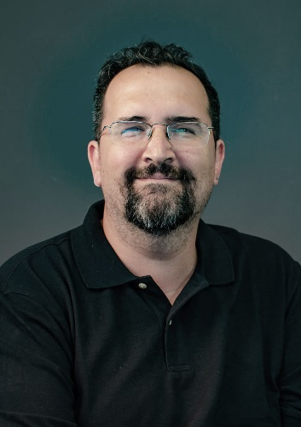
Join us in welcoming Troy, Alyssa, John, and Evren, among others, to the College at our new “Meet the new Researcher” talk series – more information coming soon!

