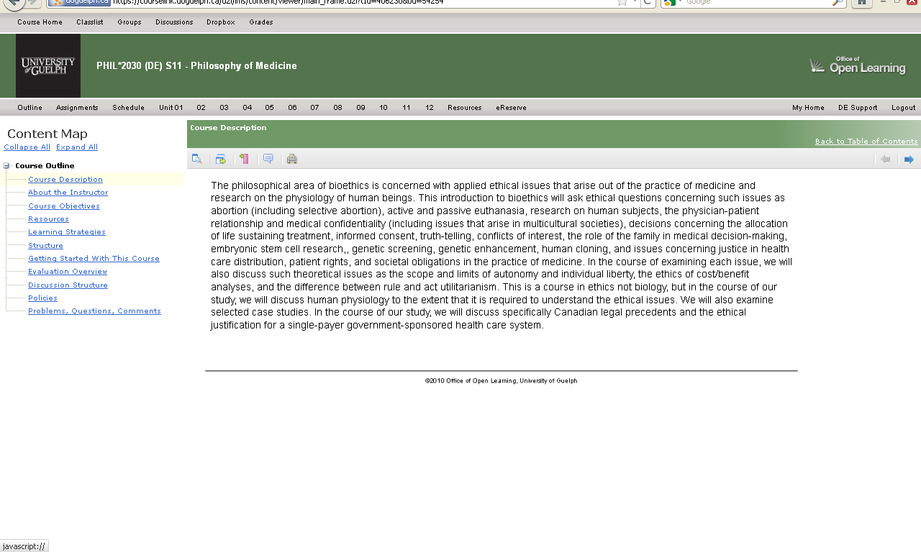

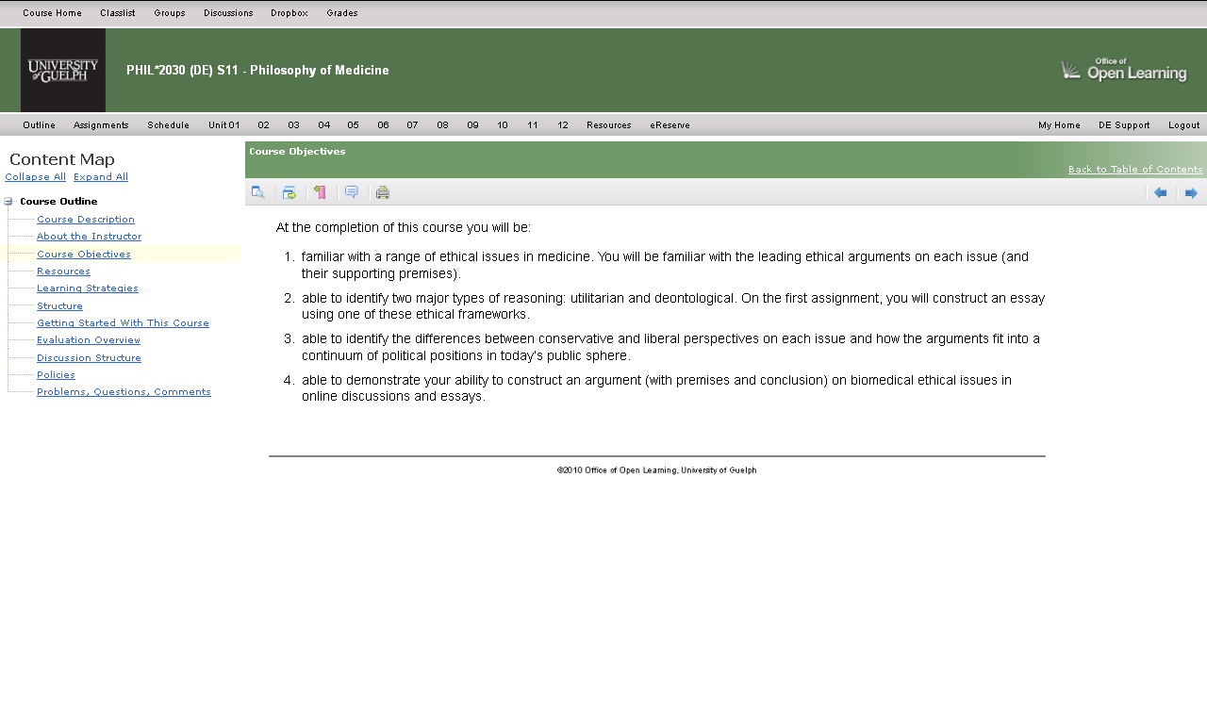Required Reading

TEXTBOOK
Biomedical Ethics: A Canadian Focus, Ed. Johnna Fisher, Oxford University Press ISBN 0195427904

Obtaining Textbooks
The textbook is available at the university bookstore.

Supplemental Reading

e-RESERVE
A selection of articles has been place on e-reserve at the library. Please see e-Reserve in the navigation bar at the top of the screen

BOOKS ACCESSED THROUGH THE LIBRARY
Imber, Jonathan B. Trusting Doctors: the decline of moral authority in American medicine. Princeton : Princeton University Press, c2008
Dunsford, Clare. Spelling Love With an X. Boston: Beacon Press, 2007.

Recommended Strategy for Course Readings
This course has a lot of required reading, the Professor’s Notes (in the Units) and the selections from the textbook. I recommend that you read the Professor’s Notes first, as the main arguments from the readings are succinctly summed-up in the Professor’s Notes. From there you can skim the readings from the textbook, with the most important points in mind.
You can go back and read the textbook readings more thoroughly once you have decided what to write your essays on. The essays will require in-depth analysis of readings you select from the required readings. The Professor’s Notes sum up the textbook reading, as well as presenting ideas and arguments that should be considered in addition to the main points from the readings.
Please see the Schedule in the navigation bar at the top of the screen for a list of readings by unit /week.
General course resources can be found via the Resources link in the navigation bar at the top of the page.
Through the use of self-tests, discussion activities, unit learning activities, reading and reflection you will meet the course objectives.
Unit 01: Course Introduction, Abortion
Unit 02: Terminating Treatment in Pregnant Women, Disabled Newborns, Stem Cell Research
Unit 03: Euthanasia
Unit 04: Euthanasia and Decisions Concerning Life Sustaining Treatment
Unit 05: Genetics and Human Reproduction
Unit 06: Genetics and Human Reproduction; Cloning
Unit 07: Confidentiality, Informed Consent, and Medical Information
Unit 08: Research on Human Beings
Unit 09: Allocation of Scarce Resources
Unit 10: The Family and Health Care in Multicultural Societies
Unit 11: Social Justice and Health-Care Policy
Unit 12: Consolidation
Units in this course match up with the 12 weeks of the course. Each week you will cover a different unit (see unit links in the top navigation bar).
Students will be assessed on the basis of two Analysis papers (5-6 pages each), discussion participation, and a Final Examination.
Guidelines for submitting written work: The essays must be double spaced. You must keep a copy of your work for your own files.
For assignment details follow the Assignment link in the top navigation bar.
Assignment Evaluation
Assignment | % of Grade
1st Analysis (5-6 pages) | 25%
2nd Analysis (5-6 pages) | 25%
Discussion Participation | 20%
Final Examination | 30%
Total | 100%
Please see the Schedule in the top navigation bar for due dates.
*Note: A course week starts on Monday and ends on Sunday. Assignments are due before Sunday 11:59 p.m. (ET) of the week in question, unless otherwise specified.
Main Discussion
I will always read this discussion and try to reply to your message within 48 hours. This discussion is public to all students in the course.
Students are required to read everything on the main discussion board, and they must log in at least once a day for this purpose. Questions other students ask may appear on the final, and you are expected to know the answers to other students’ questions that have been provided by the professor on the main discussion board. Students who ask questions that have already been answered by the professor on the main discussion board will not be answered: the professor cannot repeatedly answer the same question over and over from students who do not keep up to date with the main discussion board.
Questions and answers about the course.
Discussion for Units 02, 04, 06, 08, 10, 12
This area is focused on discussions referenced in Unit learning activities. Please be sure to complete the subject line in your messages with a well defined subject for easier later identification of messages by topic. Explore how the Discussion Search Tool works so that you can find messages later. You are free to read the messages of other groups but please only post messages to your assigned group. You will be divided into groups of 15 students for this discussion.
Group 1- public to the class
Group 2- public to the class
Group 3- public to the class etc.
You can find out which group you are in by checking the Classlist in the top navigation bar. Click on the yellow and blue “double people” icon under the “Actions” column
Coffee Shop
Relax, chat and talk about non-course related things.
Practice
Use this Discussion to learn about the course discussion system, and to practice sending and receiving messages.

Academic Misconduct

PLAGIARISM
Although students are encouraged to share thoughts and ideas while studying for the course, all material submitted for grading must be each student's own work. For clarification on Academic Misconduct, please refer to the University of Guelph's Undergraduate Calendar or the Open Learning Program Student Handbook. Please see General Resources under the Resources link in the top navigation bar.

Acceptable Use
The University of Guelph has an Acceptable Use policy which you are expected to adhere to. Please see this policy under General Resources in the Resources tab in the top navigation bar under the heading Technical.

DE Handbook
Please ensure that you have reviewed the DE Handbook (available under the DE Course Support widget on the Course Home page – right hand side mid way down ) and, if relevant, the Open Learning program handbook. In particular, ensure that you review the sections that pertain to Assignment Submissions and Returns, Online Quizzes or Tests and Final Examinations.

Course Related

Instructor Contact Information:
Name: Victoria Burke
E-mail: vburke@uoguelph.ca

Distance Education Contact Information

Technical Support:
Office of Open Learning
University of Guelph
519-824-4120 ex. 56939
Toll-Free (Can/U.S.): 1-866-275-1478
Room 153 Johnston Hall
help@open.uoguelph.ca

General Inquiries:
Office of Open Learning
University of Guelph
(519) 824-4120 ex. 55000
(519) 824-1112 (fax)
Room 160 Johnston Hall
info@open.uoguelph.ca

