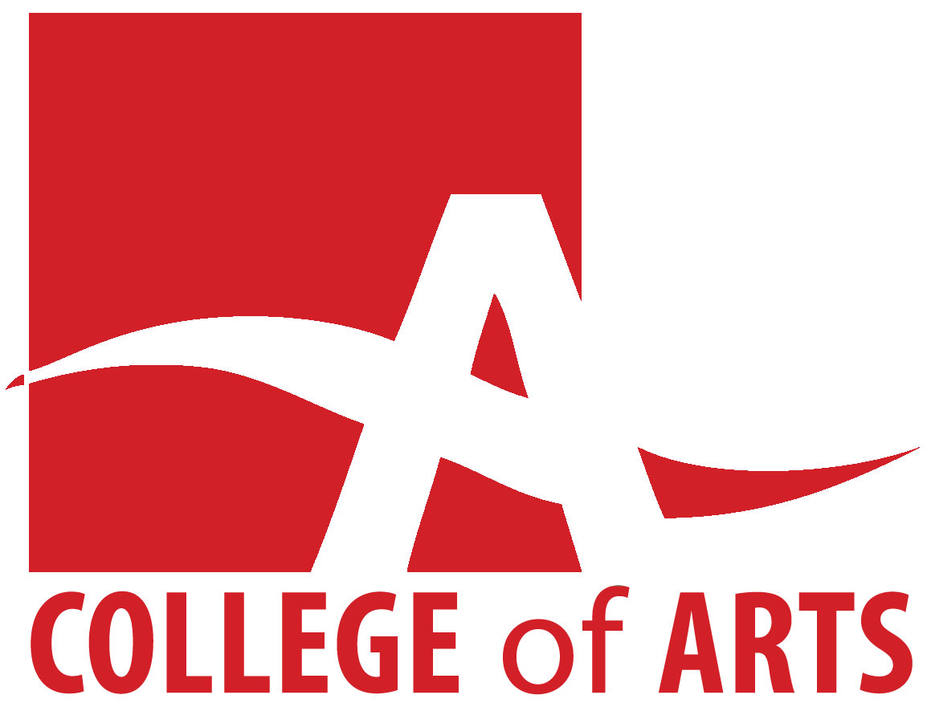
Graduate Travel, Research, and Creation Fund
The College of Arts Graduate Travel, Research, and Creation Fund is designed to help students registered in COA graduate programs to conduct travel, research, or creative activities directly related to the completion of their degrees. Each academic year, there are two competitions: one in the Fall and one in the Winter. In each competition, a total of $15,000 will be awarded. During the Fall round, the committee will consider applications for activities that have taken place since March 1 of that year, and before March 1 of the next year. During the Winter round, the committee will consider applications for activities that have taken place since November 1 of the previous year, and before November 1 of that year.

Principles
Grants will be awarded on the basis of the application’s quality and its relevance to the student’s program of study. The committee will not consider applications based on economic need. There are no fixed quotas of grants per department, school or program. The committee will make an effort to ensure that awards are distributed as broadly as possible across the college’s graduate programs, and to students at the master’s and doctoral level. To ensure that the funds are distributed broadly, the committee has set the maximum award to $1,500 and applicants will be funded for at most one research or creation activity per competition. Priority will be given in the Winter competition to students who have not already been funded in the Fall competition. The awards committee will consist of one representative from each unit (usually a graduate coordinator or designate), plus the Associate Dean (Research & Graduate Studies). The Associate Dean will chair the meetings and participate in the discussion of the applications, but will be a non-voting member except in the case of a tie.

Award and Application Timelines
For this offering, the committee will be considering applications for activities that have taken, or will take, place since March 1, 2017 and before March 1, 2018. The committee will not consider applications for activities that fall wholly outside of this time frame.

Application Process
Graduate students should complete the attached form. The completed form should be emailed to the Associate Dean, Andrew Bailey at abailey@uoguelph.ca by 5:00 pm on Tuesday, October 24, 2017. This is a firm deadline; we will not consider applications that arrive after that time. Students will be notified by email as soon as the committee has made its decisions.

Checklist
- In the email, please use the subject line: “CoA Grad Travel Application.”
- Please submit your application in pdf format if possible. Otherwise, please submit it in either rtf or doc format. Handwritten or printed applications will not be accepted.
- Please use the following naming convention: LastnameFirstname.extension; Example: a pdf submitted by John Smith would be named SmithJohn.pdf.
- Please do not submit original hardcopy receipts with your application. Your department administrator will request your receipts if the application is successful.
- If your research involves human subjects, you must submit evidence that you have applied for or received clearance from the Research Ethics Board to involve human subjects. For more information on that procedure, please go to: http://www.uoguelph.ca/research/services-divisions/ethics

Reimbursement
All expenses claimed under this award must be documented with receipts where required.

College of Arts

Application: Graduate Travel, Research, and Creation Fund

Information
Name:
University of Guelph Email:
Department:
Degree Program (e.g. MA.FREN, PhD.PHIL, etc):
Semester level:

Project
Please provide specific details of your proposed research, travel, or creative activity, and explain how it is related to your program of study. Please note that ‘research’ here is interpreted broadly to include the research/creative activities that students in the College of Arts conduct as part of their degree programs.

[Project description here: 250 words maximum].

Dates
Dates of your trip/research/creative activity

Budget
Please provide budget details. The committee prefers to see concrete and specific budgets, rather than general estimates. You are encouraged to provide supporting documentation (for example flight itineraries, hotel rates for your proposed dates of travel, etc.). Note that the maximum award this fund will grant is $1,500.

International Travel:
Domestic Travel:
Accommodation:
Conference Fees:
Other (please itemize):

Total:

Other Funding
Have you previously received research funding from the College of Arts beyond the GTA and scholarship support outlined in your letter of admission?

If yes, indicate when, how much, and for what purpose:

Have you received funding from any other source (University or external) for this activity?

