**RURAL HISTORY ROUNDTABLE  **

**WINTER 2012**

## This is the 10th Anniversary of the Department of History Rural Roundtable series, University of Guelph.

Name: **Dr. Catharine Wilson**

Title**: “'Bees-Gone-Wrong': The Untold Story about Neighbourhoods and the Good Old Days of Threshing and Barn Raising Bees in Ontario"**

*Bio: Dr Wilson is Professor of History at the University of Guelph and Coordinator of the Rural History Roundtable*

Date: Monday Jan 23, 2:30-4:30

Location: OAC Boardroom, Room 104, Johnston Hall, University of Guelph

Name: **Patricia Bowley**

Title: **"Soybeans and Ontario Crop Agriculture, 1880s-1970s: Responding to a Century of Challenges on the Farm"**

*Bio: Pat Bowley is a doctoral candidate in the Department of History at theUniversity of Guelph.*

Date: Tues Feb 7, 10:30-12:30

Location: OAC Boardroom, Room 104, Johnston Hall, University of Guelph

Name: **Becky Beausart**

Topic**: “Beyond Tea Parties and Calling Cards: Women and Domestic Leisure in Late-Nineteenth and Early-Twentieth Century Rural and Small-Town Ontario”**

Bio: *Rebecca Beausaert is a PhD candidate in the Department of History, York University.*

Date: Tuesday 28 Feb 10:30-12:30

Location: OAC Boardroom, Room 104, Johnston Hall, University of Guelph

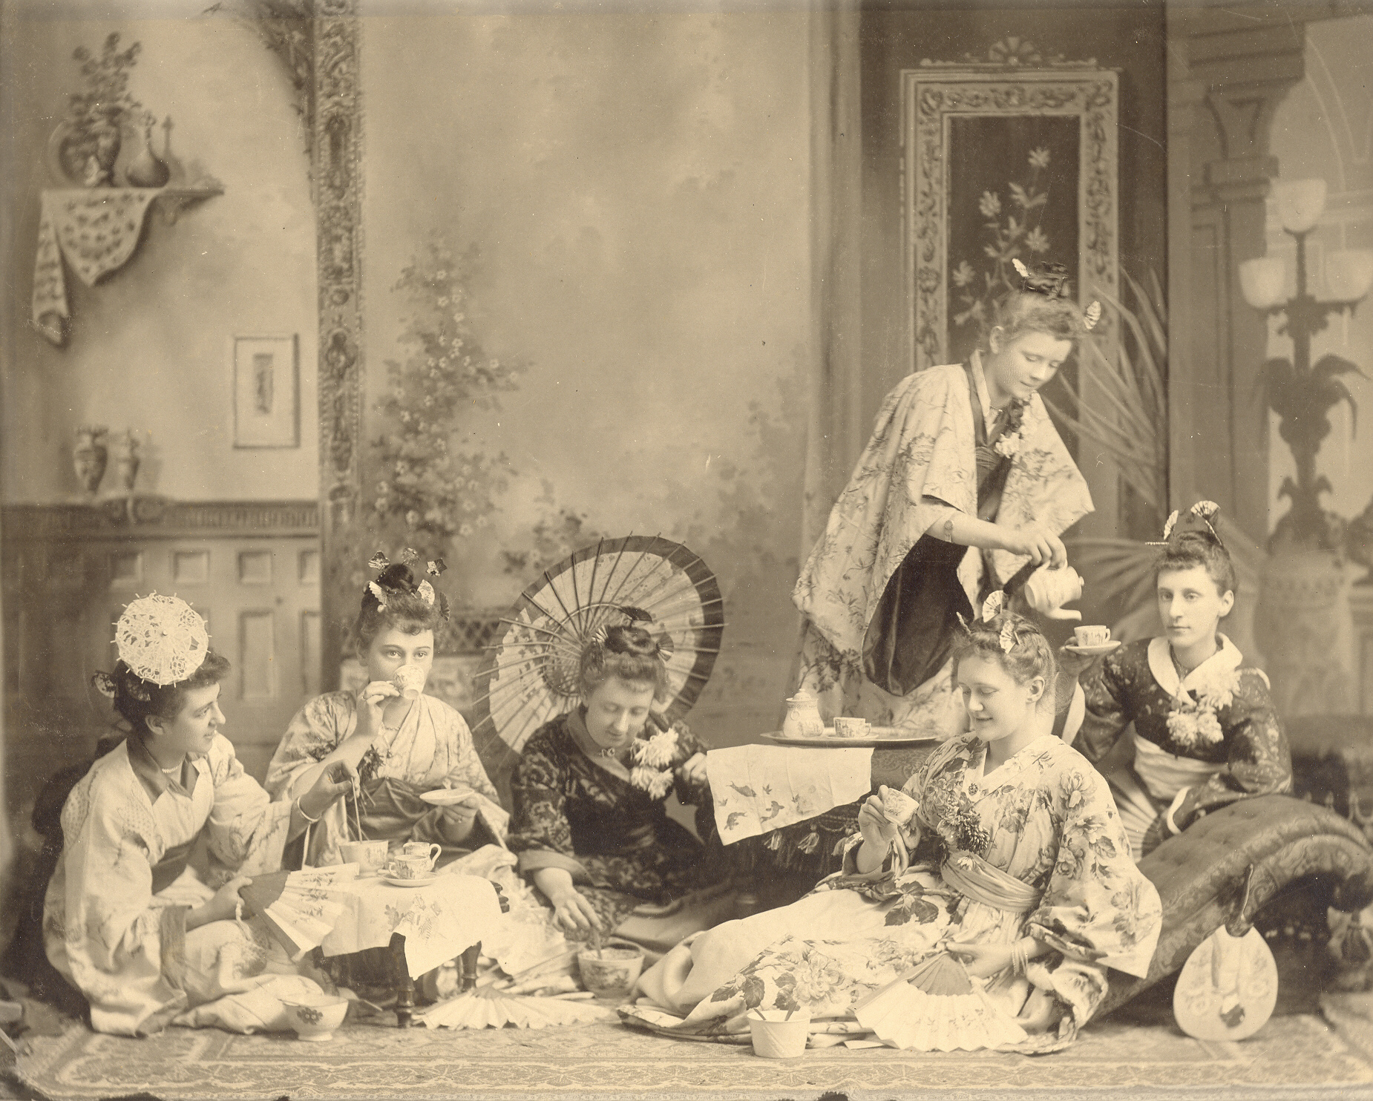

Name: **Dr Kevin James,**

Title: **The Inn, the Hotel & the Tourist: Narratives of Rural Irish Travel Accommodation, 1**[**801-1926**](callto:+1801-1926)

*Bio: Dr Kevin James is Associate Professor in the Department of History; he is a member of the Scottish Studies faculty and his interests lie in Scottish and Irish tourism history and comparative social history.*

Date: Tuesday, 13 March, 10:00-12:00

Location: OAC Boardroom, Room 104, Johnston Hall, University of Guelph

Name: **Andrea Gal**

Title: **“A Glimpse into the Everyday Consumption Patterns of Early Twentieth Century Rural Ontario Families”**

*Bio: Andrea Gal is a PhD candidate at Wilfrid Laurier University*

Date: Wednesday April 4, 10:00 to 12:00

Location: OAC Boardroom, Room 104, Johnston Hall, University of Guelph

