School of Fine Art and Music/School of LAnguages and Literatures

Winter Semester 2022

ARTH/CLAS3150

Space: Roman Art and Urbanism

INSTRUCTOR: Dr. Martina Meyer

TIME: M/W 9:30-10:20 Lecture (subject to change)

F / 9:30-10:20 Virtual / Zoom
LOCATION: MacKinnon 114
OFFICE: McKinnon 247
PHONE: 519-824-4120
EMAIL: meyerm@uoguelph.ca

OFFICE HOUR: Friday, 10:30-11:30 Virtual / Zoom by appointment
ARTH/CLAS3150
Course Description
This course explores the purposes, meanings, materials, and messages of Roman art, architecture, and urban organization over the course of 1200 years, from the founding of a village on the Palatine hill along the Tiber River in the 8th century BC to the Mediterranean basin in the late 4th century AD. Emphasis is placed on geography, chronology, materials/media, and cultural identity as Rome transitions from one of hundreds of competing city-states in Italy to an Empire. Consequent changes in the art, architecture, and organization of urban spaces in Rome, Italy, and across the Roman world are explored both synchronically (within a given period of Roman history) and diachronically (across periods) in relation to significant historical events and subtle cultural trends. Portrait busts, statuary, wall and floor surfaces, furniture, decorations, utensils of all shapes and sizes, public and private structures, and even entire cities are analyzed as reflections and conveyors of the identity, interests, aspirations, and social, economic, religious, political, and military preoccupations of the human beings who commissioned or “consumed” them.
Course Goals:
- To provide an introductory knowledge of the topography, history, daily life, and material remains of ancient Rome and Roman towns in the bay of Naples.
- To improve the ability to see and experience space, and, particularly, to be able to describe those experiences in a meaningful way.
- To identify basic architectural styles and building materials used by the Romans.
- Develop insights Roman history, daily life, and culture.

Learning Outcomes:
- Identify the major sites and artifacts of the ancient Roman world, from the early first millennium CE to the reign of Constantine
- Interpret how these sites and artifacts contribute to our understanding of the history and culture of the ancient Romans
- Analyze different types of material evidence, including ceramics, architecture, inscriptions, and coins, and to use them to address research questions
- Distinguish between interpretations of evidence and the evidence itself
- Synthesize information and ideas orally and in writing
Required Texts:
S. L. Tuck, A History of Roman Art. Chichester: Wiley Blackwell 2015. An eBook version is available.
Useful Texts
  - E. d'Ambra, Roman Art in Context: An Anthology. N5760 R64 1993
  - L. Farrar, Ancient Roman Gardens. SB458.55 F37 1998
  - J. Hall (ed.), Etruscan Italy: Etruscan Influences on the Civilizations of Italy from Antiquity to the Modern Era. DG223.3 E88 1996
  - W. MacDonald, The Pantheon: Design, Meaning, and Progeny. NA323 M3X 1976
  - J.-A. Shelton, As the Romans Did: A Sourcebook in Roman Social History. HN10.R7 S45 1998
  - J. Stambaugh, The Ancient Roman City. HT114 S7 1988
  - J. Berry, The Complete Pompeii. London: Thames & Hudson 2013. DG70.P7 B468 2013
  - A. Boëthius, Etruscan and Early Roman Architecture. New Haven: Yale University Press 1978. NA300
  - D. Favro, The Urban Image of Augustan Rome. Cambridge: Cambridge University Press 1996. DG69
  - D. Kleiner, Roman Sculpture. New Haven: Yale University Press 1992. NB115 K57 1992
  - R. Ling, Roman Painting. Cambridge: Cambridge University Press 1991. ND120 L56 1990
  - W. MacDonald, The Architecture of the Roman Empire. New Haven: Yale University
  - A. Wallace-Hadrill, Rome's Cultural Revolution. Cambridge: Cambridge University
  - J. Ward-Perkins, Roman imperial Architecture. New Haven: Yale University Press 1981. NA310 W34
  - K. Welch, The Roman Amphitheatre: From Its Origins to the Colosseum. Cambridge:
  - P. Zanker, The Power of Images in the Age of Augustus. Ann Arbor: University of Michigan Press 1990. N5763 Z36 1988
Term Evaluation
Midterm (Feb. 28th) 30%
10 Discussion posts (initial & response) 20%
Final Exam: Take Home Essay (Distributed April 8 and due to Dropbox April 15) x 35%
Group presentation (Week 12) x 15 %
Late papers and make-up tests: As the dates of exams and due dates of assignments will be included in the Course Outline, all students are expected to know about them and to be prepared accordingly. For those who miss a mid-term test for medical or compassionate reasons, the grade will be redistributed to the other exams. There will be NO make-up tests.
Schedule
Week 1 (Jan 10 12 14):
M/W: Introduction. The Etruscans; Death and Burial & Boundaries
Readings: Tuck, Chapters 1 and 2
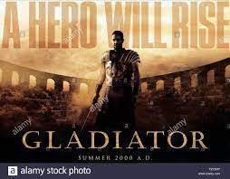
F: Discussion 1: Cinematic Rome can be considered self-referential. Whether Italian nationalism, American humanism, wartime propaganda, or post-colonial rebellion, films about ancient Rome have been understood as parables about now, rather than then; us, rather than them. Rome is a site where otherness is expected to be played out: dictatorship and the world wars, women and orientalism, immorality, and religion. It has been a way to talk about empire, nationalism, ethnicity, class, gender - and is associated with scale, spectacle, and excess. What image of ancient Rome does popular culture communicate?
Week 2 (Jan 17 19 21):
M/W: The Republic; Verism is Truth and Honour
Reading: Tuck, Chapter 3
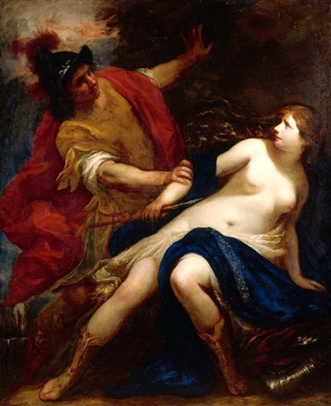

F: Tarquin and Lucretia, https://jamanetwork.com/journals/jamapsychiatry/fullarticle/482608
https://crossworks.holycross.edu/cgi/viewcontent.cgi?article=1007&context=parnassus-j
Discussion 2: Ancient Rome is founded on violence. What attitudes towards masculine and feminine identities are valued? How do the visual arts communicate these ideas? Do we continue to share in these ideals? Explain with reference to visual culture.

Week 3 (Jan. 24 26 28):
M/W: Roman Religion and the Roman Temple; Roman Building Methods and Materials
Reading: Tuck, Chapter 4
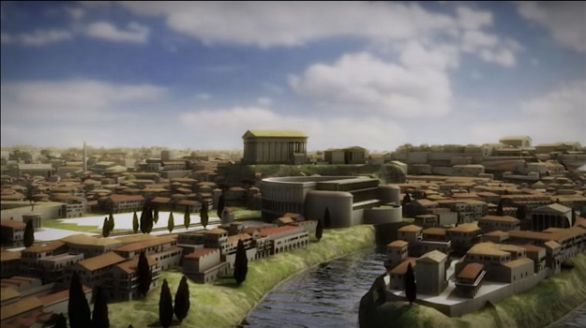
F: https://penelope.uchicago.edu/~grout/encyclopaedia_romana/architecture/templearchitecture.html
https://www.khanacademy.org/humanities/ancient-art-civilizations/roman/roman-republic/a/jupiter-optimus-maximus
https://www.bbc.com/travel/article/20211213-how-are-romes-monuments-still-standing
Discussion 3: What message does this structure communicate? How does art /architecture achieve the message?
Week 4 (Jan 31 Feb 2 4):
M/W: The Roman House and Mural Painting. Read: https://www.metmuseum.org/toah/hd/ropt/hd_ropt.htm
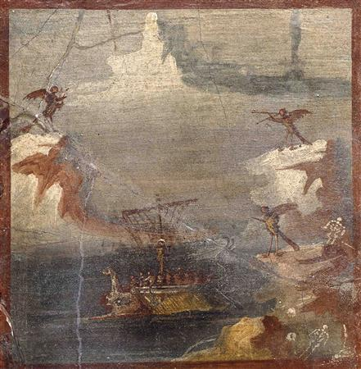

F: https://theconversation.com/walking-talking-and-showing-off-a-history-of-roman-gardens-138902
https://www.thecultureconcept.com/an-ancient-roman-villa-a-cultural-ideal-of-rural-life-pt-2
Discussion 4: To what extent have we inherited our ideas towards nature from the ancient Roman world?
Week 5 (Feb. 7 9 11):
M/W: Augustan Rome I
Readings: Tuck, Chapter 5; Augustus, Res Gestae (https://www.livius.org/sources/content/augustus-res-gestae/
: 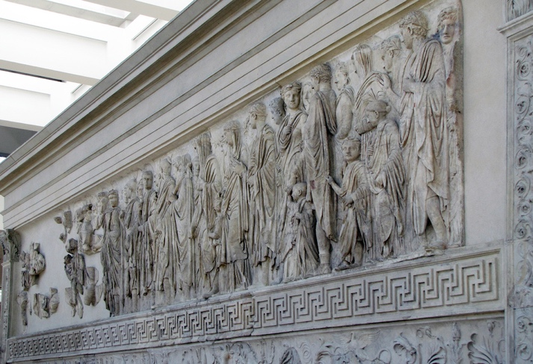
F: https://smarthistory.org/ara-pacis/
Discussion 5: Propaganda has always been a significant role played by the visual arts. How effective was Roman material culture in communicating ideas? Has anything changed?
Week 6 (Feb. 14 16 18):
M/W: The Julio-Claudians, Architecture & Propaganda, Commemorative Monuments; Rome’s Population, Society and Freedom
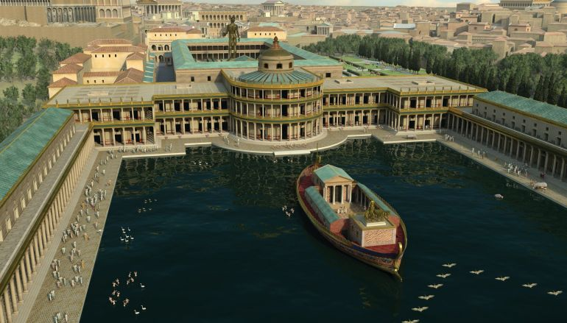
F: https://www.archaeology.org/issues/187-1509/features/3562-golden-house-of-an-emperor
Discussion 6: The Domus Aurea. Are we a culture of excess?
Reading Week Feb. 21-25
Week 7 (Feb 28 Mar 2 4)
M: Midterm (Feb. 28)
W/F: Roman Portraiture, Sculpture and Painting
Reading: Tuck, Chapter 6; Portraiture and Gender. Looking the Part: Transcending Gender in the Portraits of Agrippina the Younger, by Kristin M. Hébert. Courselink
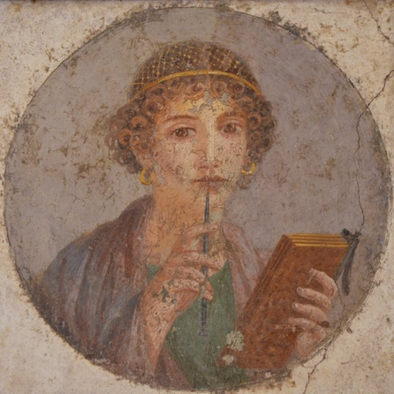
Week 8 (Mar 7 9 11)
M/W: Rome of the Flavians; Public Venues
Readings: Tuck, Chapter 7 Colosseum, Ludus Magnus, Circus Maximus
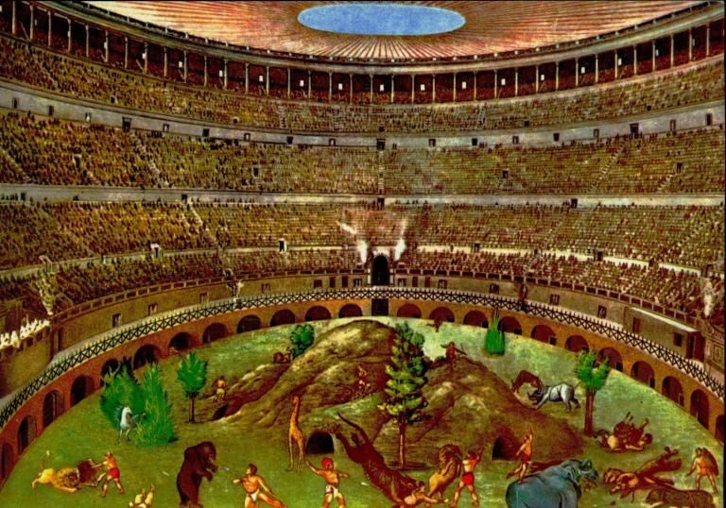
F: Power, Brilliance and Brutality” The Flavian Amphitheatre. https://depts.washington.edu/hrome/Authors/jimkuo2/IlColosseo/pub_zbarticle_view_printable.html
https://exhibitions.kelsey.lsa.umich.edu/galleries/Exhibits/Empire2/intro/flavians.html
Discussion 7: What connects this ancient monument with the contemporary world? What do we owe to the Roman world view? To Roman understanding of human psychology? To Roman engineering?
Week 9 (Mar 14 16 18)
M/W: Rome of Trajan and Hadrian, Roman Water Supply, The Pantheon, The Markets and Forum of Trajan, Column of Marcus Aurelius, Temple of the Deified Hadrian, Stadium of Domitian, Tomb of Bibulus, The Imperial Fora
Readings: Tuck, Chapters 8 and 9
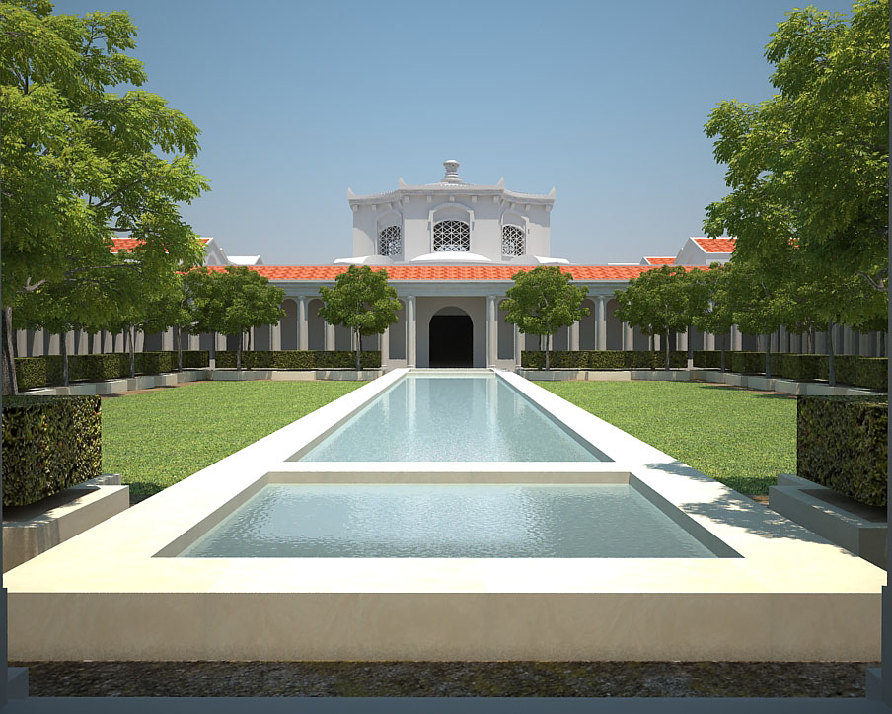

F: Hadrian’s Villa, https://www.realmofhistory.com/2020/03/14/superb-animation-showcases-restored-hadrians-villa-glory/
Discussion 8: In what ways has this famous work of domestic architecture shaped ideas about cultural assimilation, collecting ethics, viewing?
Week 10 (Mar 21 23 25)
M/W: Port Cities and Commerce
Readings: Tuck, Chapter 10, and www.ostia-antica.org for individual monuments
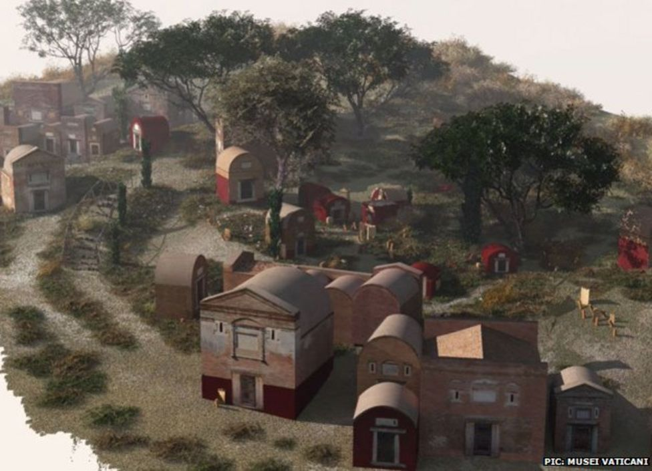
F: Life and Death in the provinces and Rome’s Roadside cemeteries. https://archaeology.co.uk/articles/coriniums-dead-excavating-the-tetbury-road-roman-cemetery.htm
https://www.bbc.com/news/world-europe-25421841
Discussion 9: What image can we construct of Roman attitudes towards death, family, remembrance from funerary imagery?
Week 11 (Mar 28 30 Apr. 1)
M/W: Decline and Transformation: Constantine; Transformation to a Christian Rome
Arch of Constantine, Baths of Caracalla
Readings: Tuck, Chapter 12
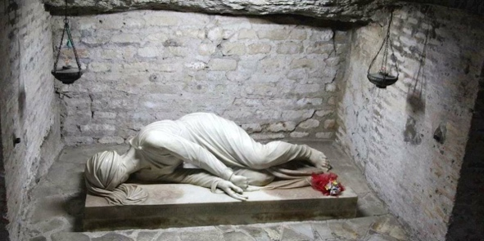
F: Catacombs and Early Christian Art, https://reformedperspective.ca/romes-catacombs-art-was-created-to-encourage-fellow-christians/
Read section #2 (Catacombs) https://depts.washington.edu/hrome/Authors/calaroni/Enterintotheunderground/pub_zbarticle_view_printable.html
Discussion 10: In what ways is early Christian art an example of visual syncretism?
Week 12 (Apr. 4 6 8)
M/W/F Group Presentations
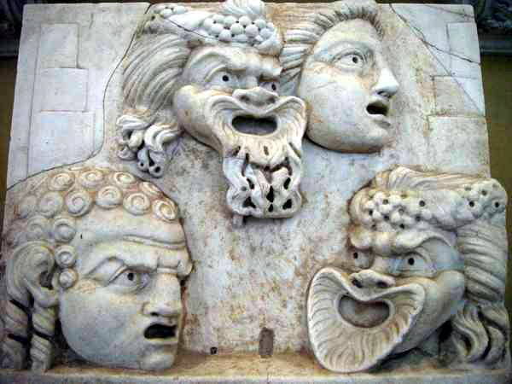
Each group will select a single specific object*(painting, sculpture, architecture, decorative art (i.e., metalwork, jewelry, book illustration etc.) and discuss its significance, first within its cultural moment and secondly its influence on visual culture.
*Each selection must be unique (no two groups can present the same object so it will need to be approved by me).

