Study Abroad – Centre for International Programs
The School of Fine Art & Music and the School of Languages and Literatures
SORRENTO ITALY
May 24 – June 27 - Five weeks of art, language, travel, sun/sand/sea – earn 1.5 credits!!!!
INFORMATION SESSION THURSDAY, NOVEMBER 21, Alexander Hall Room 286 at 5.30 pm
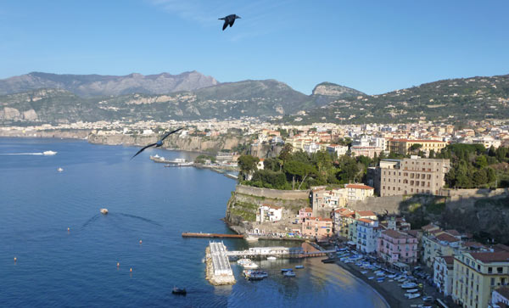
This five-week Field School gives U of Guelph students an opportunity to live and study in Sorrento, Italy at the Sant'Anna Institute on the beautiful Amalfi coast. While living in the heart of the Mediterranean, in residence accommodations at the Institute, students will take an Art History course – HUMN 3600 – Women of Ischia: Poets, Painters and Printers – for 1.00 credits and can also take an Italian language course appropriate to their knowledge of Italian (beginner, intermediate or advanced) for 0.5 credit equivalent at U of G (the Italian language course is optional).
The Art History course, which will include field trips to Ischia, Capri, Naples and an option to travel to Rome, will be taught by Dr Sally Hickson from the School of Fine Art & Music.
**Students from all disciplines are eligible and encouraged to apply to the Italy Field School.
APPLY THROUGH Centre for International Studies (CIP) Guelph
FOR MORE DETAILS: https://www.uoguelph.ca/cip/italy-field-school-women-ischia-renaissance-poets-printers-and-intellectuals

When Late May-June 2020 (5 weeks)
Location Sant’Anna Institute Sorrento, Italy
Course/Credit 1.0 credit Women of Ischia—Renaissance Poets, Printers and Intellectuals
A field school course taught by University of Guelph faculty.
0.5 credit An Italian language course taught by Sant’Anna faculty (all levels possible)
Cost approx. $5,600* + airfare
Information Session November 27, 2019
4:00 p.m.| St. Jerome’s University |SJ2 2007
Registration deadline January 24, 2020
Questions? Please email klappinfortin@uwaterloo.ca
or rcauchis@uwaterloo.ca
*Field school fee = approx. $3,800 (includes accommodation and trips to Pompei, Naples, Ischia, and Capri). Tuition fees = approx. $1,800 ($1,200 for 1 credit, $600 for .50 credit course).

