Quick Start Guide
University of Guelph Campus Press Theme
Updated October 3, 2019

Theme Options
There are five theme options tabs found in Appearance > Theme Options: Global, Widget Areas, Home Page, My Profile, and Contact + Social.

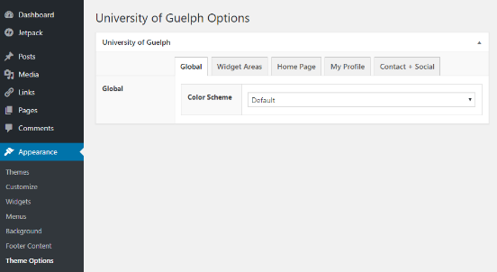

Under the Global tab, you can choose a colour scheme that aligns with University of Guelph brand colours. The chosen colour scheme will be applied to your site’s main menu.

Under the Widget Areas tab, you can choose which widget areas (Right Sidebar, Left Sidebar, Top Full and Footer Full) are visible on specific templates. These templates include:
- Post Listing Page
- Post Page
- U of G About Page / Blog Posts Template
- U of G About page / Offset Template
- Right Sidebar Layout
- Left Sidebar Layout
- Left and Right Sidebar Layout
- U of G About Page / Full Width

Under the Home Page tab, you can edit content on the “U of G Home template” (see Page Layouts section for further details).
- Home Slider: Add a slideshow in place of the static background image on your homepage. After clicking Add New > Slide, you will be able to add an image, headline, secondary headline, and optional link for the slide.
- Home Intro: Provide an introductory paragraph on the homepage
- Home Labels: Change the labels of the Publications, News, and Twitter widgets.
- Home Sidebar: Hide the Twitter widget completely.

Under the My Profile and Contact + Social tabs, you can enter a profile pic, profile details, your email address and links to your various social networks. This information will be used to automatically populate section of pages using the “U of G About” page templates (see Page Layouts section for further details).

Page Layouts
There are several templates that can be applied to pages when creating or editing them. Page template options will be found in the right sidebar of the editing screen in the Document > Page Attributes area.

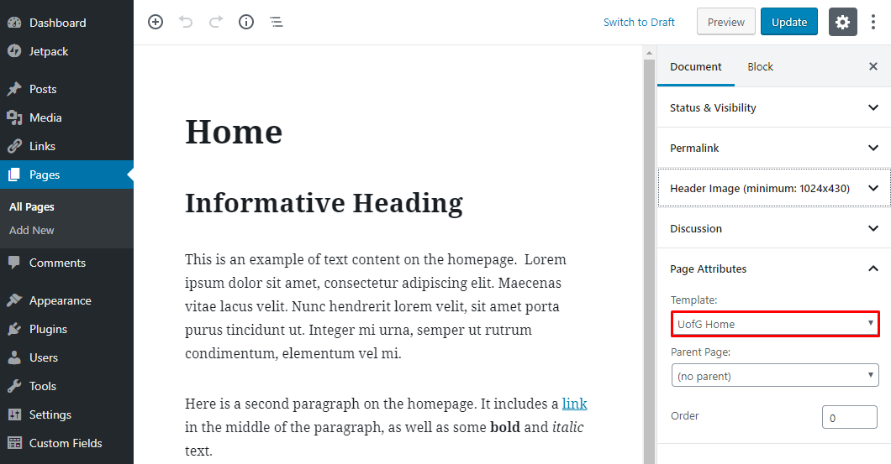

Default Templates
These templates allow you to show a page with or without the Left and Right Sidebar widget areas. They also allow you to show content in the Top Full and Footer Full widget areas.

- Default Page (no sidebars)
- Right Sidebar Layout
- Left Sidebar Layout
- Left and Right Sidebar Layout

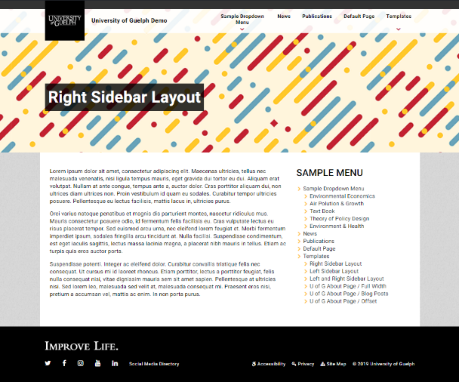

Additional Templates

U of G Home Template
View Demo of U of G Home Template

- (Optional) Displays a slideshow populated from Theme Options > Home Page
- (Optional) Displays the tagline and long bio from Theme Options > My Profile.
- (Optional) The “Latest Publications” section displays the 3 most recent posts from the “Publications” category.
- (Optional) A “Lab News” section displays recent posts from the “News” category.
- (Optional) An “On Twitter” section at the bottom of the sidebar adds a Twitter feed pulled from the Twitter account added to Theme Options > Contact + Social.
- Any other content added to the page will show up under the prepopulated sections listed in items 1-5.

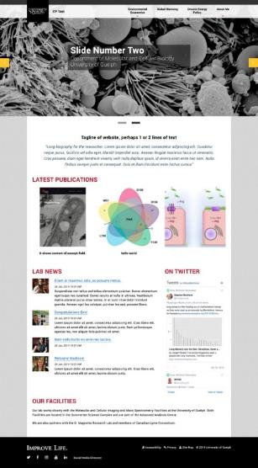

U of G About / Blog Posts Template
View Demo of U of G About / Blog Posts Template

- Displays the page title in the header.
- Blog posts from the “Blog” category are displayed in the body of the page.
- Has access to the Left Sidebar and Right Sidebar widget areas.

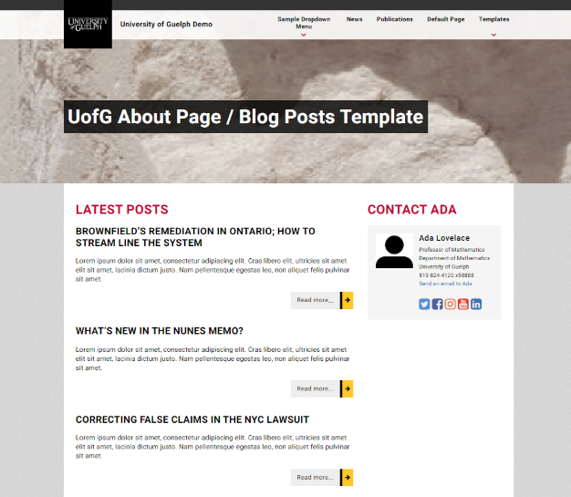

U of G About / Full Width Template
View Demo of U of G About / Full Width Template

- Displays the page title in the header.
- Uses the full width of the page and is well suited to using the About Heading (U of G) Content block and About Content (U of G) block.
- Has access to the Top Full and Footer Full widget areas.

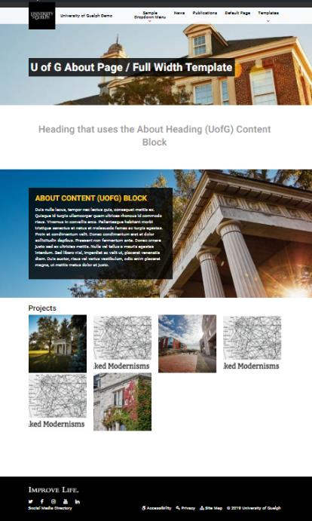

U of G About / Offset Template
View Demo of U of G About / Offset Template

- Displays the page title at the top of the page.
- Displays the profile picture and short bio from Theme Options > My Profile.
- Has access to the Left Sidebar and Right Sidebar widget areas.

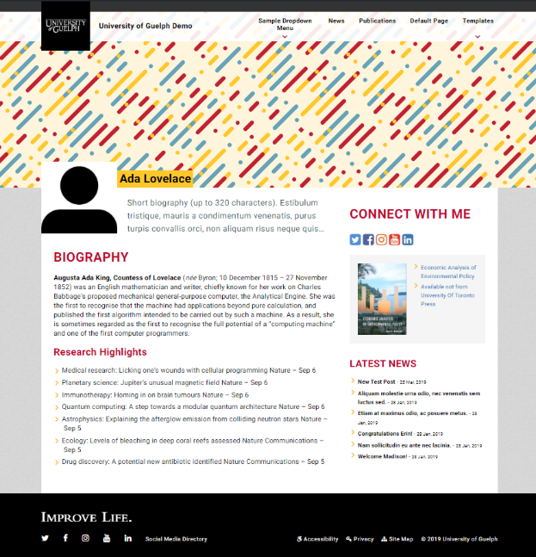

Custom Widgets

Layout Blocks Template
There are also three custom U of G blocks you can use when building pages: About Heading (U of G), About Content (U of G), and Profile Listing (U of G). These blocks can be used with all templates; however, they work best with the U of G About / Full Width page template.

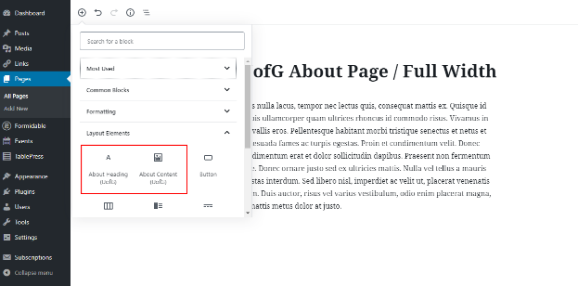

About Heading (U of G) Block
This block will add a customized heading area to your page. Rather than use the default styling, this will add a clean, grey heading.

About Content (U of G) Block
This block allows you to add three types of content: a background image, an about heading, and your about text.

You add the background image by clicking the image icon in the top left corner, and then enter the heading and content by clicking on the placeholder text.

- The heading in this block will be yellow and the about text will be white. All text is placed in a dark grey text box.
- If a background image is set, the text box will be set on top of this image.

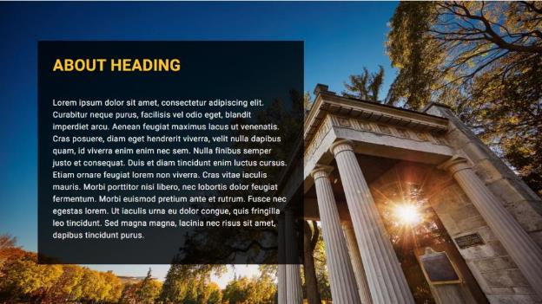

Project Listing (U of G) Block
This block displays a heading “Projects”, followed by a grid of images (4 columns with rows added as needed). Each image links to a post categorized by the “Projects” category.

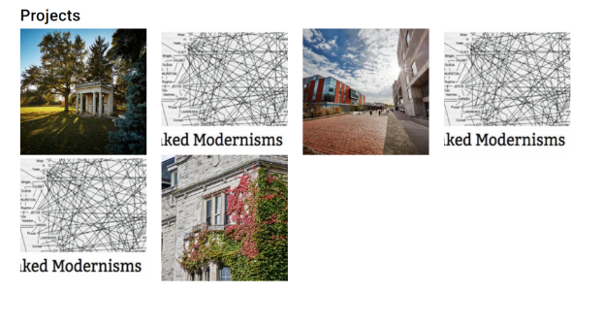

Sidebar Widgets
There are three custom U of G widgets that you can add to widget areas: Social Icons (U of G), Contact (U of G) widget, and Latest News (U of G). The suggested use for these custom blocks would be to add content to the Left Sidebar, Right Sidebar, Top Full, or Footer Full widget areas. Campus Press provides guidance on adding widgets and controlling the visibility of widgets. (Note that the Widget Visibility plugin should already be installed on your website.)

Social Icons (U of G) Widget
This widget displays a heading “Connect with Me” followed by links to your various social networks, populated by Theme Options > My Profile.

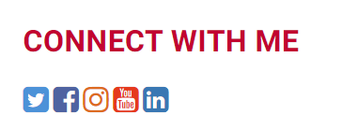

Contact (U of G) Widget
This widget displays a heading “Contact <Profile Name>” with the Profile Name populated by Theme Options > My Profile. This is followed by a profile pic, profile details, your email address and links to your various social networks.

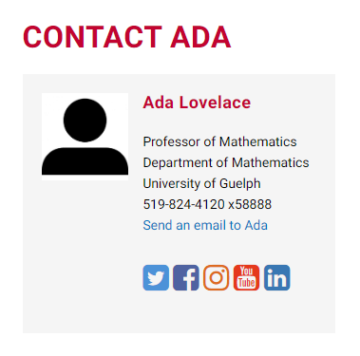

Latest News (U of G) Widget
This widget displays a heading “Latest News” followed by links to the most recent posts categorized by the category “News”.

