

ECON*3810.01

Advanced Macroeconomics

Fall 2026 (0.5 Credits)

General Course Information
Instructor: |  | Stephen Kosempel
Email |  | kosempel@uoguelph.ca
Office Location |  | MacKinnon 746
Office Hours |  | Tuesday & Thursday 12:00 – 1:00 PM or by appointment
Department/School |  | Department of Economics and Finance
Class Schedule: |  | T/Th 10:00 – 11:20 AM; MCKN 121
Pre-requisites: |  | ECON*2410, ECON*2740 or STAT*2040, ECON*2770 or MATH*1210
Teaching assistant: |  | TBA

Course Description
This course provides an advanced study of a wide range of issues in intertemporal macroeconomics. When constructing macroeconomic models in this course we will explicitly take into account microeconomic foundations. The models constructed will be used to study short-run fluctuations (or business cycles) and long term growth, and to explain cross country income disparities. Topics also include open economy macroeconomic issues.

Course Learning Outcomes
Knowledge and Understanding:
- Mathematical Methodology: Students are expected to solve systems of equations, optimization problems and to analyze systems of first-order difference equations.
- Statistical and Econometric Methodology: Students have to be familiar with data analysis, and regression analysis.
- Macroeconomic Modeling: As an advanced course, ECON*3810 introduces students to macroeconomic dynamics. Students are expected to understand and to recognize various concepts and models.
- Historical and Global context: Students will be required to research the values of current macroeconomic indicators and variables. Short essay questions will ask students to construct an argument about a macroeconomic issue from an historical perspective and formulate a solution for a current macroeconomic problem.
- Economic Policy and Regulation: Students must understand and explain the macroeconomic consequences of the various forms of government intervention.
Discipline/Professional and Transferable Skills:
- Written Communication: Short answer questions will be graded with the usual essay writing criteria except for the requirement of a bibliography.
- Problem Solving: Students will have to calculate various macroeconomic indicators, solve various general equilibrium models with one or two sectors. Students will also have to make quantitative predictions and to use graphical analysis to demonstrate and interpret the various economic models. All these skills will be assessed in the midterm and final examinations.
- Real World Applications: Students will have to apply the course materials to historical and current macroeconomic problems.

Summary of Course Content and Materials
The course is organized into three sections: (i) one-period macroeconomic models emphasizing the consumption–leisure choice; (ii) two-period models examining consumption–saving decisions and asset pricing; and (iii) longer-horizon models used to study economic growth and development.

Course Assessment and Grading Policies

Exams: The examinations will cover all material presented in lectures, and in the textbook chapters identified below. Midterms 1 & 2 and the final exam account for all of your final grade. Your highest two exam scores will have weights of 40% and your lowest will have a weight of 20%.
 |  |  |  | Associated Learning Outcomes | Due Date/ location
Midterm 1 |  |  | Chapters 3-5 | All | In class
Midterm 2 |  |  | Chapters 9-11 | All | In class
Final exam |  |  | Chapters 3-11 | All | TBD
Midterm Examinations are scheduled to take place face to face and during class time following the completion of Chapters 5 and 11. The format is quantitative problem(s) and short answer question(s), and may include some multiple choice questions. Writing at an alternative date/time will only be granted on the basis of valid medical or personal reasons, and needs to be requested via email to the instructor as soon as possible. The format of the alternative exam may differ from that specified above.

Final Examination: A Final Examination is scheduled to take place face to face.

Students who find themselves unable to meet course requirements by the deadlines or the criteria expected because of medical or personal reasons, should review the regulations on academic consideration in the Academic Calendar and discuss their situation with the instructor, program counselor or other academic counselor as appropriate.
http://www.uoguelph.ca/registrar/calendars/undergraduate/current/c08/c08-grds.shtml

Course Resources
Required Textbook
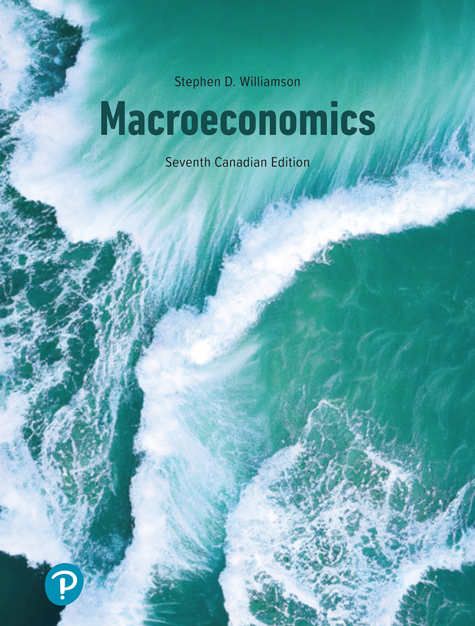 | Author: Stephen Williamson  Title: Macroeconomics, Seventh Canadian Edition  Publisher: Pearson 2026  Cost $71.99 CAD

The e-Text can be purchased from our University Bookstore: https://www.bookstore.uoguelph.ca/booklist.aspx

Additional resources will be available at: https://courselink.uoguelph.ca/shared/login/login.html

University Policies

Academic Consideration
When you find yourself unable to meet an in-course requirement because of illness or compassionate reasons, please advise the course instructor in writing, with your name, id#, and e-mail contact. See the academic calendar for information on regulations and procedures for Academic Consideration: http://www.uoguelph.ca/registrar/calendars/undergraduate/current/c08/c08-ac.shtml

Academic Misconduct
The University of Guelph is committed to upholding the highest standards of academic integrity and it is the responsibility of all members of the University community, faculty, staff, and students to be aware of what constitutes academic misconduct and to do as much as possible to prevent academic offences from occurring.
University of Guelph students have the responsibility of abiding by the University's policy on academic misconduct regardless of their location of study; faculty, staff and students have the responsibility of supporting an environment that discourages misconduct. Students need to remain aware that instructors have access to and the right to use electronic and other means of detection. Please note: Whether or not a student intended to commit academic misconduct is not relevant for a finding of guilt. Hurried or careless submission of assignments does not excuse students from responsibility for verifying the academic integrity of their work before submitting it. Students who are in any doubt as to whether an action on their part could be construed as an academic offence should consult with a faculty member or faculty advisor.
The Academic Misconduct Policy is detailed in the Undergraduate Calendar:
https://www.uoguelph.ca/registrar/calendars/undergraduate/current/c08/c08-amisconduct.shtml

Accessibility
The University of Guelph is committed to creating a barrier-free environment. Providing services for students is a shared responsibility among students, faculty and administrators. This relationship is based on respect of individual rights, the dignity of the individual and the University community's shared commitment to an open and supportive learning environment. Students requiring service or accommodation, whether due to an identified, ongoing disability or a short-term disability should contact Student Accessibility Services as soon as possible.
For more information, contact SAS at 519-824-4120 ext. 56208 or email sas@uoguelph.ca or see the website: https://wellness.uoguelph.ca/accessibility/

Course Evaluation Information
Please refer to the Blue by Explorance system.

Recording of Materials
Presentations which are made in relation to course work—including lectures—cannot be recorded or copied without the permission of the presenter, whether the instructor, a classmate or guest lecturer. Material recorded with permission is restricted to use for that course unless further permission is granted.

Drop date
The last date to drop one-semester courses, without academic penalty, is Friday, December 04, 2026. For regulations and procedures for Dropping Courses, see the Academic Calendar:
https://www.uoguelph.ca/registrar/calendars/undergraduate/current/c08/c08-drop.shtml

