Ikigai
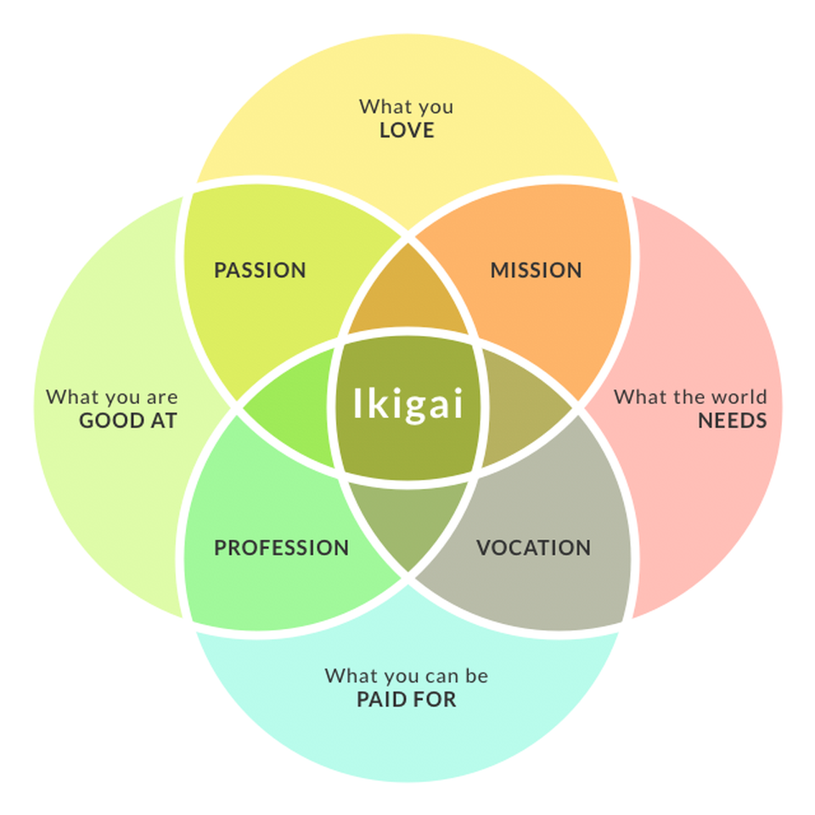

What did you love about this job?

What were you good at?

What did you do that you could be paid for in the future?

What did you do during this experience that the world needs?

Moving forward after this workshop, dig deeper into the Ikigai model by answering these questions from a bigger picture perspective, beyond your summer research position. Consider the areas of overlap and how they could contribute to a career path or potential industries of interest.

Here are some examples.

What the world needs:
Vaccines
What you love:
Writing

What you can be paid for:
Mental Health Knowledge
What you are good at:
Building Relationships

Communications Assistant for a company researching vaccines

Fundraising Associate for a mental health organization

Proud Moments Exercise:
Recall a time when you did something you were proud of. Don’t limit yourself to work or school—draw on all areas of your life, past and present: work, leisure, learning, home, creative pursuits, volunteering and relationships with family and friends. Try to think of at three experiences. For each, ask yourself these questions to remember as many details as you can:
- What did I do?
- When did this happen?
- What was the result?
- Why did it make me proud?
1)______________________________________________________________________________________________________________________________________________________________________________________________________________
2)______________________________________________________________________________________________________________________________________________________________________________________________________________
3)______________________________________________________________________________________________________________________________________________________________________________________________________________
As the Listener:
Summarize what you’re hearing and ask them probing questions to get to the root of the strengths shared in the story. Write down the skills you think they used. Try to help your partner find themes or connections among the three moments they share. For example:
- It sounds like that involved a lot of [skills], is that right?
- How do you think those two experiences are similar?
- What impact did that have on those around you?
- What challenges did you overcome?
____________________________________________________________________________________________________________________________________________________________

Values Card Sort Activity

Go to https://www.think2perform.com/our-approach/values

Go through the deck once, clicking ‘add’ on any values that resonate with you and skipping ahead on any that that do not. When you’ve gone through the deck once, click ‘Save Values & Continue’. Then, narrow down your values to the top 15.
Next, reduce the deck down to your top 10. What are your top 10 values?

Finally, narrow things down to your top 5 values and write them below.

Reflection:
What was difficult about selecting these top 5? Why did these make the cut?

Discuss the impact of these values on your satisfaction in current and past jobs.

How do you imagine you would feel if you were in a role that did not fulfill these values?

What steps could you take to investigate the presence of these values in future potential careers and employers?

Making Sense of Career Options

A Framework for CAREER EXPLORATION
Finding your career path requires research, self-reflection, and using insights gained to form connections between your skills and interests and career opportunities. Below are some trusted resources to help you get started on your own career research. Happy searching!
Explore options:
- Begin your research by exploring the careers with a simple Google search.
- Get career information using O*NET (an American source), the Job Bank (a Canadian resource that allows you to access information about job profiles, skills & knowledge, wages and outlooks, and job postings though the “Menu”), and Career Cruising (a Canadian resource that allows you to access information about careers including job description, sample career path, educational requirements and more via written means as well as recorded interviews with people working in those careers; Username = uguelph, Password = careers).
- Use job boards like Indeed and Job Bank to play around with keywords related to your field of study and learn about career opportunities, requirements and employer needs.
- Search for further education programs with keywords using UniversityStudy.ca, The Michener Institute, OntarioColleges.ca, GradSchools.com and eCampusOntario (directory of online courses/programs).
- Google search professional associations and societies related to these fields. You can also use the Career Cruising website to find these under “Other Resources” when viewing career information.
- Think about the different industries or companies that would hire for these positions and how that might make the job look or feel different. For example, you could work as a Marketing Assistant for a startup tech company or an insurance organization; which are you drawn to and why?
- What challenges do you want to work on or what problems would you like to solve? Find companies that work on those challenges and problems.
- Keep track of your research, questions and insights using a spreadsheet or notebook.
- Follow-up with a Career Advisor as needed.
Reflect on your Knowledge, Skills and Attitudes:
Identifying the knowledge, skills, and attitudes (KSAs) you are gaining through your studies, work and volunteer experience, extra-curricular activities, and through experiential learning opportunities can help you not only identify suitable career options for yourself, but also uncover clues about how to market yourself for those opportunities based on what employers are looking for.
- Look through the lists and definitions and reflect on which KSAs you have, those you wish to develop, and those you enjoy using.
- Think of a specific example of each of the KSAs in action.
Additional Resources:
- Explore Experiential Learning opportunities using our catalogue.
- Use LinkedIn to research alumni from your current and potential future programs. Where did their careers start? Where are they now?
- Find out more about your personality, interests, values, and work preferences.
- Thinking of a gap year? Find out more about how to make it intentional.

