When someone is creating a requisition and moves back to a previous screen

This error may appear: “An error has occurred in building your approver list. Please contact your system administrator” To correct the error, click on the Manage Approvals button
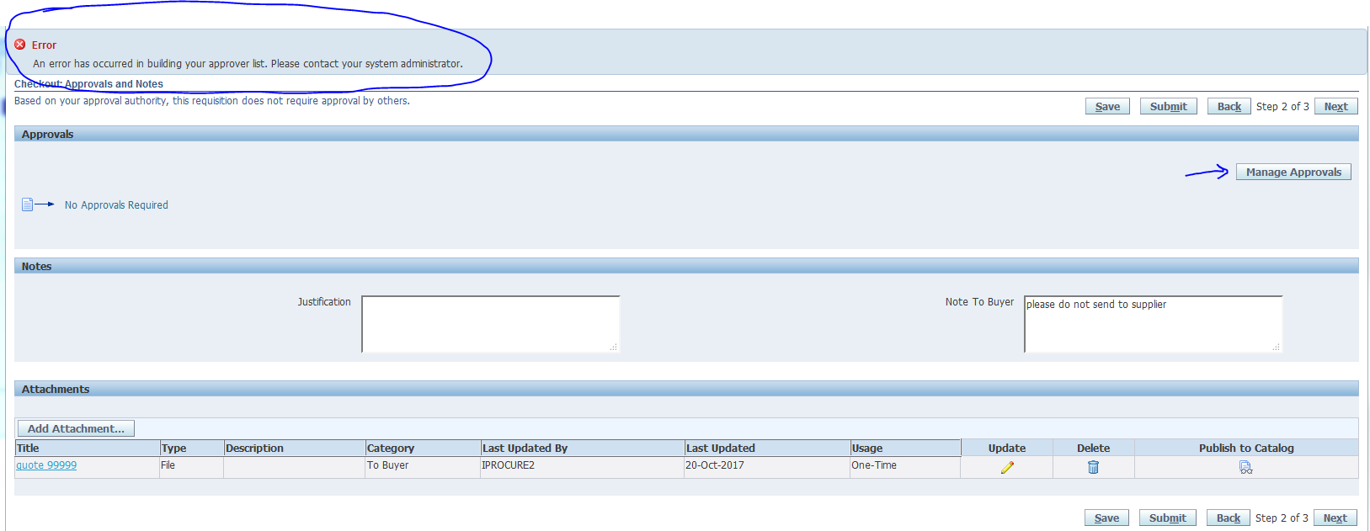
Select “Reset Approver List”:
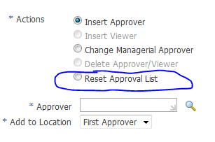
Then submit button. This will return the you to the Step 2 of 3 screen. Select “Next”, which takes you to Step 3 of 3. Then submit:
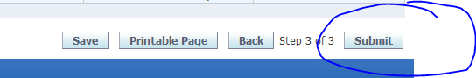
Requisition will proceed without error now. 