Selection requisition and click on the Change button:
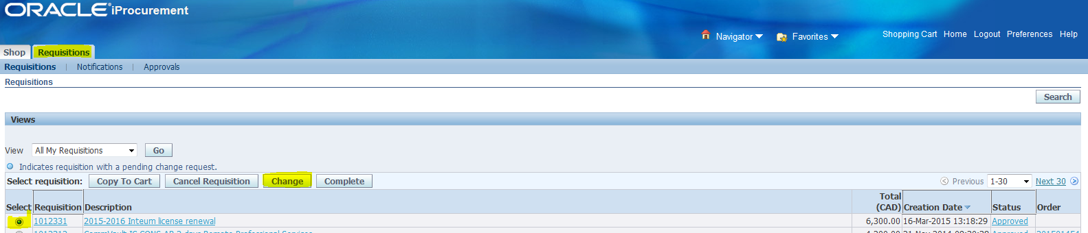
Answer yes to the question if this screen appears:
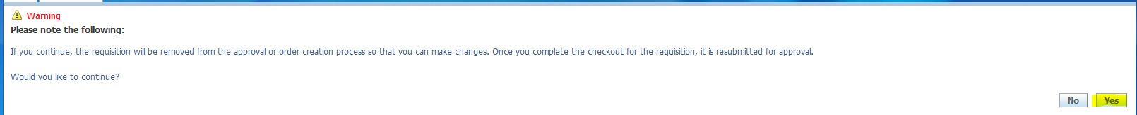
For the next screen click on checkout:
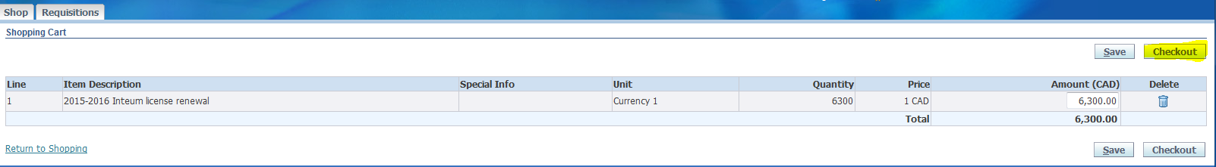
From the screen below, click on Next:
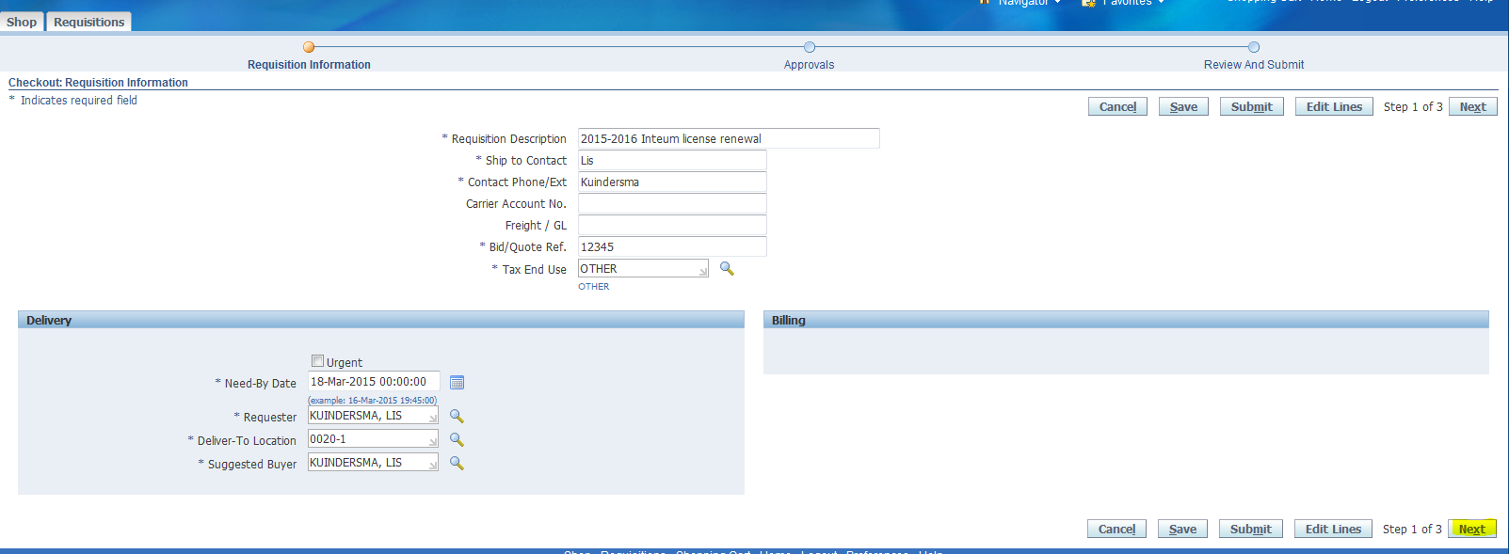

Click on add attachment…
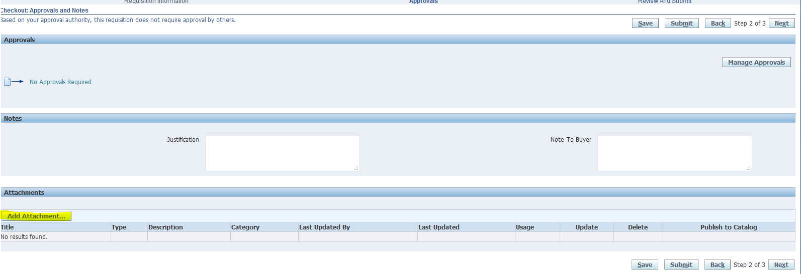
This will take you to the following screen to add your attachment. Add the title for your attachment, then click on the “Browse…” button to find the file to attached.
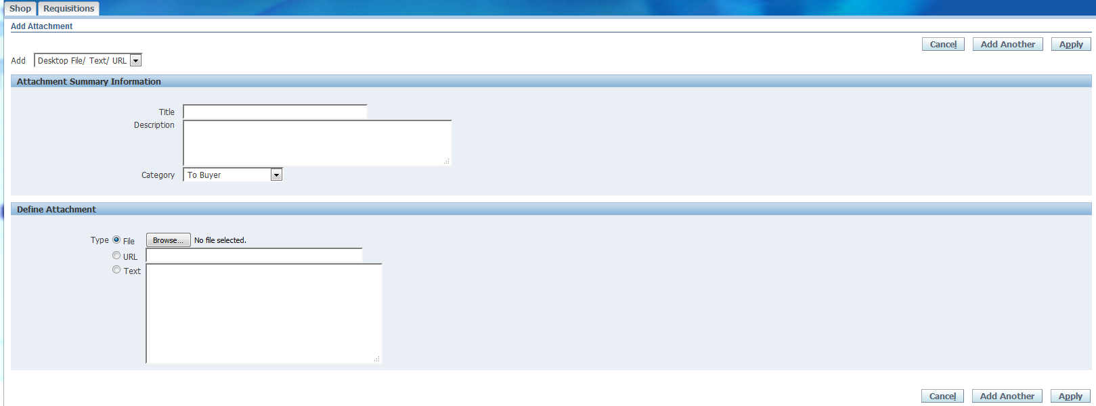

A file upload window will pop-up to allow you to pick the file to attach. Select the appropriate file and click on the open button.
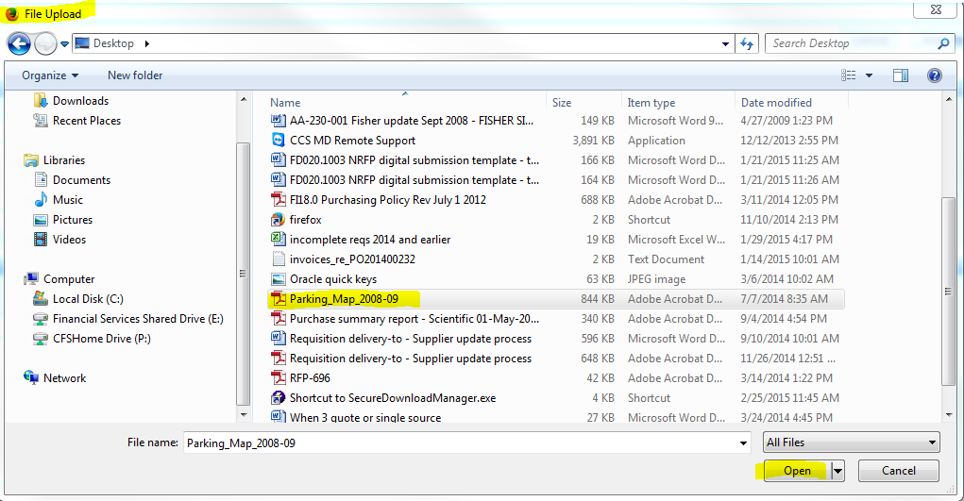

The following screen will appear. If you have more attachments, click on the “Add Another” button and repeat the process. If you are done with adding attachments, click on the “Apply” button.
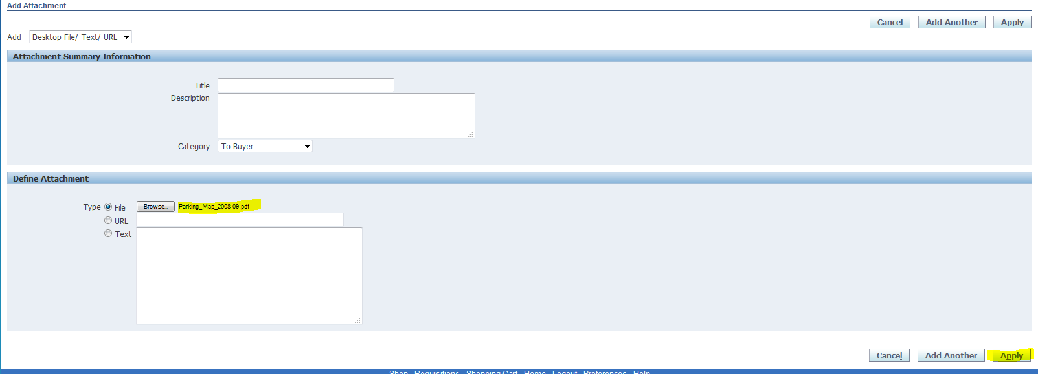

The followind Screen will appear. Click on the “Submit” button. 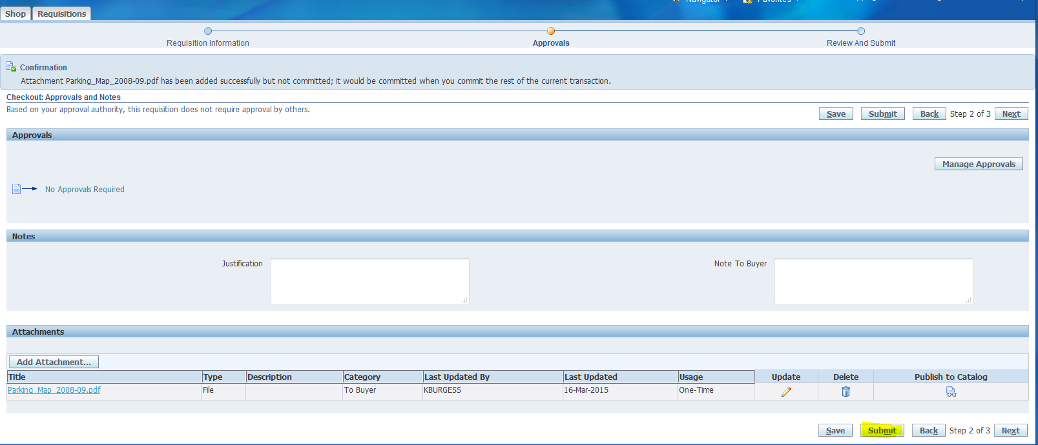
You are now finished adding attachments:
