Selection requisition and click on the Change button:
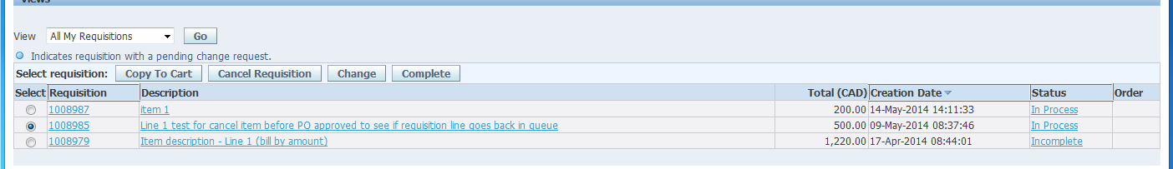
Answer yes to the question if this screen appears:
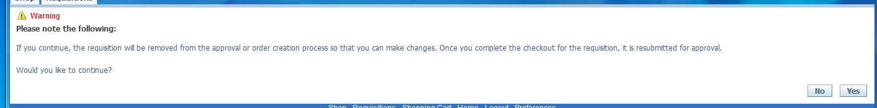
For the following screen click on checkout:
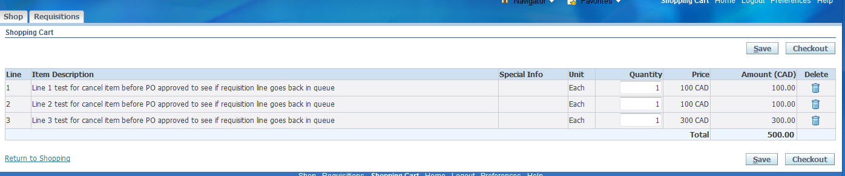
From the screen below, click on Edit Lines:
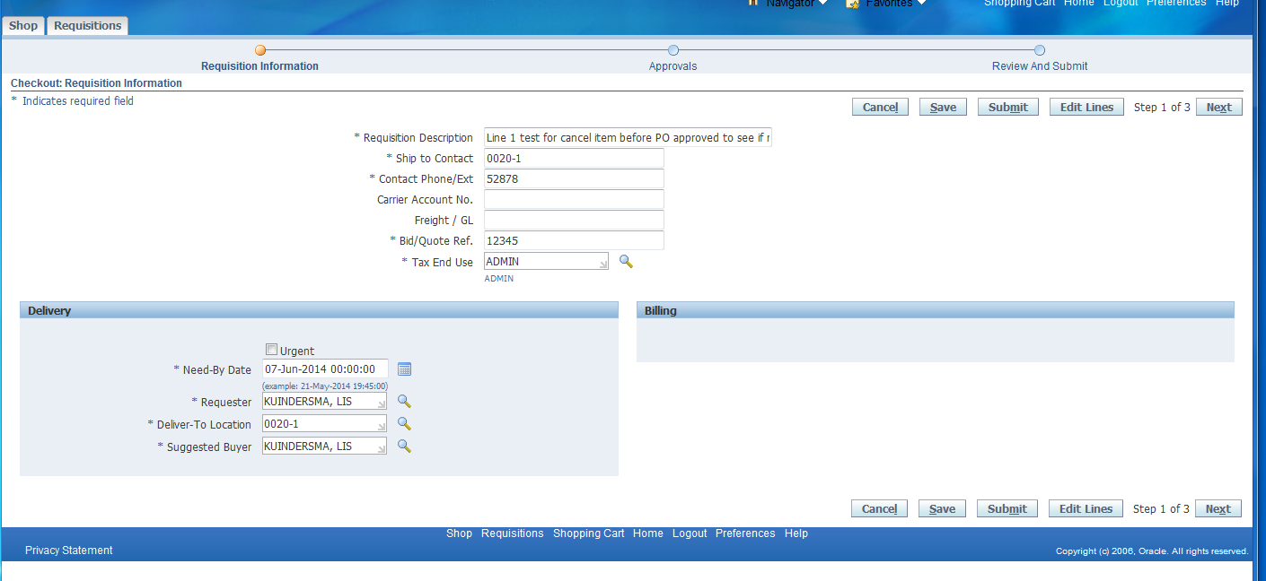

To update the supplier information it needs to be done one line at a time.
So select one line then click on the update button.
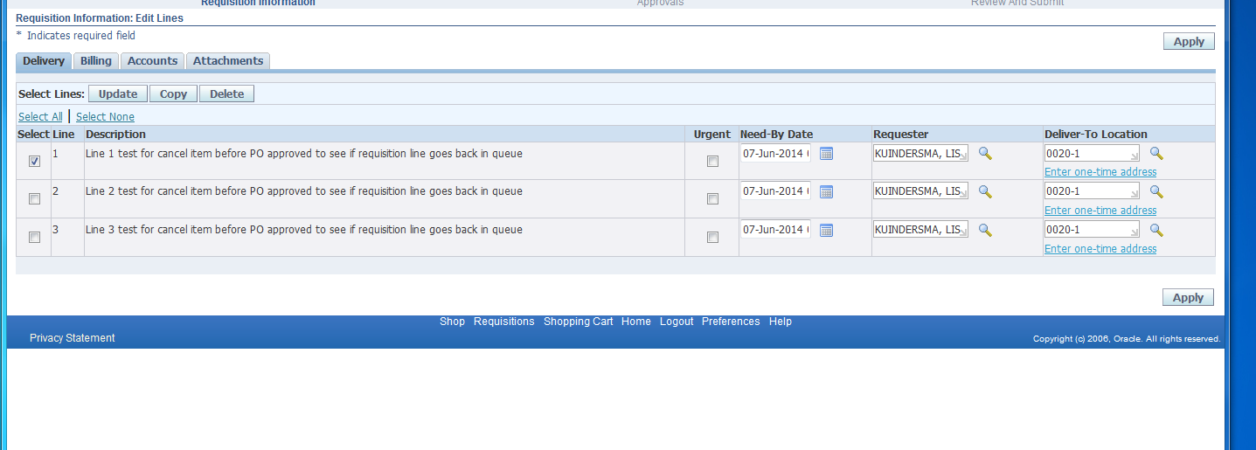
This will take you to the Supplier information which can be updated. The Deliver-To information can also be updated on this screen and currency. Once updated click on the apply button.
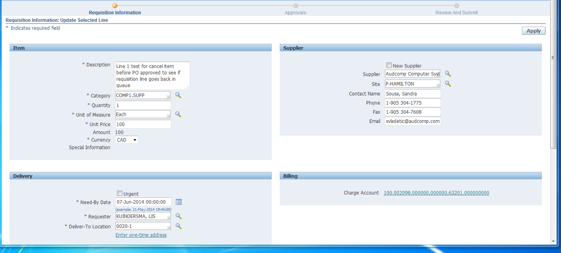
This will take you back to the edit lines screen. Update the supplier (and/or deliver-to) information for each line. Once the supplier has been updated on all lines, click on the apply button.
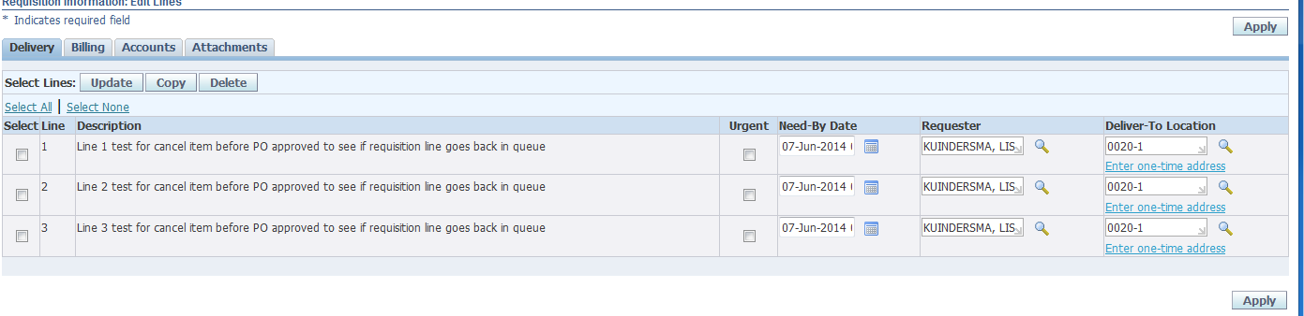
That will bring you to the following screen:
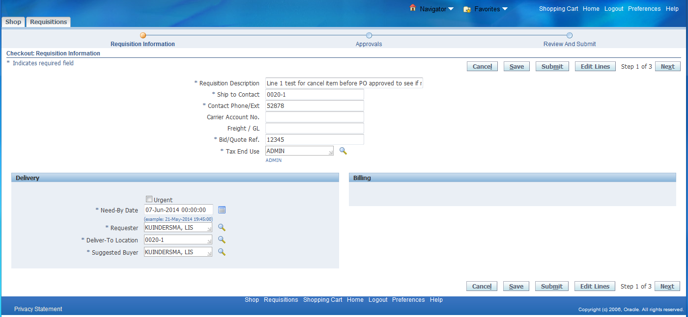
Click on the submit button to resubmit the updated requisition.

