Quick Steps to Add a New Department User as a Department Admin

Step 1:
From the Home screen select “Dept” (you can click on Dept. or click the dropdown arrow then select “Dept contacts”) you will see your name and information relating to yourself.

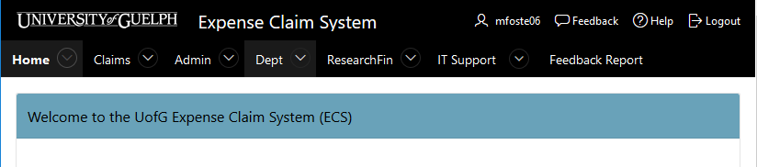

Step 2:
Select the “Show All Dept. Users” button by clicking on the blue highlighted people icon in that column.

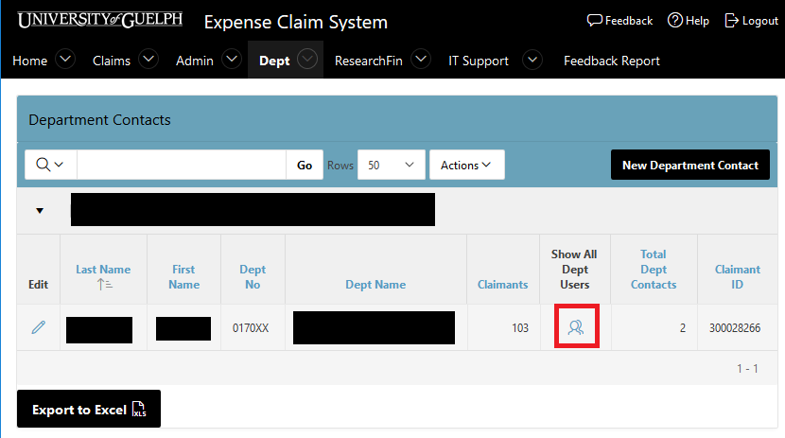

Step 3:
Select “New Dept. User”.

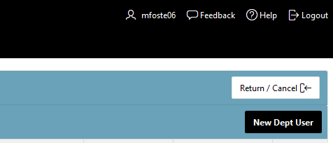

Step 4:
Select the button highlighted below to bring up the employee list.
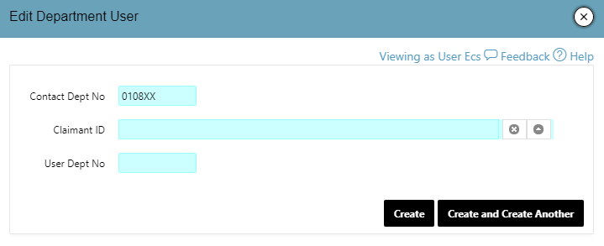

Step 5:
Search for the new user and then select them from the given list by clicking on their name.

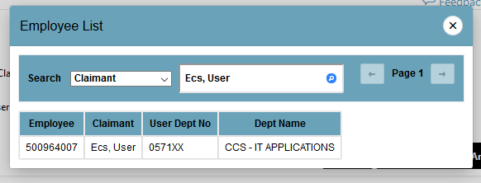

Step 6:
Select “Create” to create the new Department User.

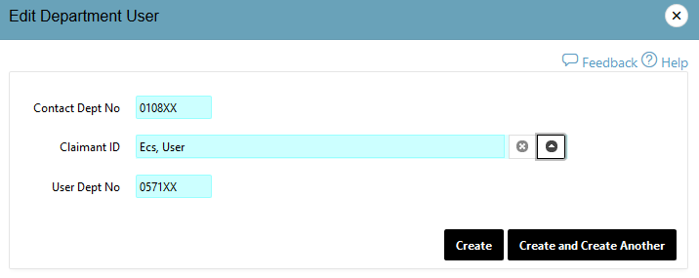

NOTE: If you would like to add a new dept. user and they are not in your department list you will need to contact ECS at: ecs@uoguelph.ca
Please provide the following information in your email request:
Claimant Name
Claimant ID #
Department #

