- Clarification on Category Code WASTE.SUPP
Some requisitioners have asked what purchases should use WASTE.SUPP code. Please note this category is specifically for Hazardous Waste Disposal. We have changed the description for WASTE.SUPP to Hazardous Waste Disposal:
EHS has a campus wide hazardous waste management program in place, for detailed information please refer to EHS website
https://www.uoguelph.ca/hr/hr-services-environmental-health-safety-programs-laboratory-safety/hazardous-waste
- We have made some changes to the iProcurement screen. We hope these changes will make it easier for you to enter a requisition.

- Tips for certain fields are added or updated.
- These tips appear as the smaller blue text under the field box.
- They are helpful information and guidance related to the field above.
- We have updated and added some new ones throughout the screens.
Example:

- We have removed the two fields currently not in use: “Contract Number” and “New Supplier”.
Before  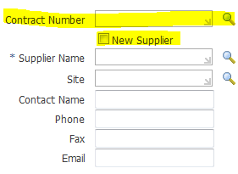 | After  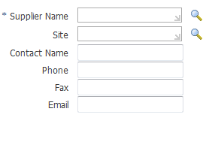
- The field “Tax End Use” has been removed.
Before  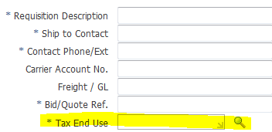 | After  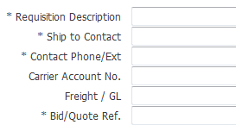

- “Deliver-To Location” field has been renamed to “Ship-To (####%)”, and the “Requester” field has been renamed to “End User”.
Before  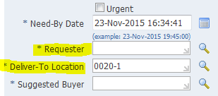 | After  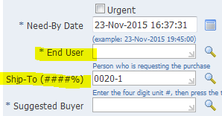
- The End User field refers to the person who needs/uses the products/services in your department. It doesn’t refer to the person who enters the requisition (requisitioner), which is tracked by the system automatically.
- The Ship-To format should begin with the four digit unit number, such as 0020-1.
- When an End User is selected, the Ship-To field will be automatically populated with the department name for the end user. Requisitioner needs to remove the department name and enter the correct Ship-To in required format.

- In Add Attachment screen, the default category has been changed from “Internal to Requisition” to “To Buyer”.
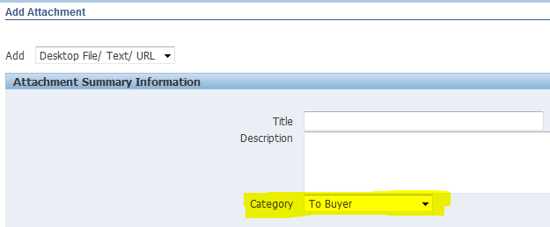
Above changes will go into effect on December 14, 2015. If you have any questions regarding above updates, please contact myreq@uoguelph.ca.

