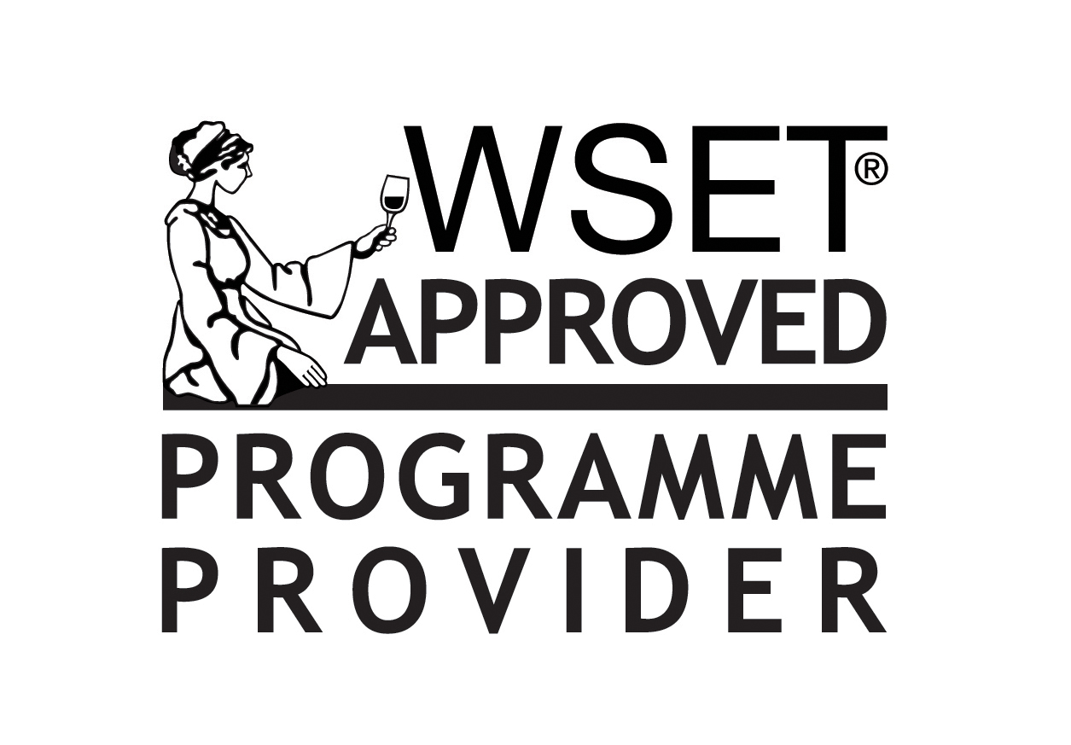

Wine & Spirit Education Trust
Approved Program Provider
APP 1458
Complaints Procedure
Complaints against any action or practice which threatens the integrity of the Wine & Spirit Education Trust courses, either the APP staff, instructor or student should in the first instance be discussed with the APP contact at the University of Guelph, School of Hospitality, Food & Tourism Management.
The APP undertakes to investigate all complaints in a thorough and professional manner. This includes, but is not limited to:
• Notifying the complainant that their complaint will be investigated by a named
individual within a given time frame;
• Informing the complainant of the outcome of the investigation in writing;
• Informing the complainant of the appropriate escalation of the complaint if the
initial outcome is still unsatisfactory.
An outline of the problem and the main points should be documented and dated. If the problem is still not resolved at this stage the candidate should contact a higher authority in the College or the WSET.
Some examples of complaints include:
• Dis-satisfaction with the teaching, facilities or administration of WSET courses;
• Allegations of discrimination or unfair treatment;
• Falsifying results or assisting candidates with answers;
• Allowing unauthorized material into the exam room, i.e., cell phones, notes, etc.;
• Allowing candidates to copy from each other;
• Disruptive behaviours, e.g. talking during the exam.

