Request for Proposals (RFP) - KFLA Regional Centre for Healthy Aging Ancillary Studies Competition  Program Guidelines | 

Purpose
The Canadian Frailty Network (CFN) is looking to fund high-quality research, knowledge translation and implementation of innovation in practice studies on healthy aging carried out in the Kingston, Frontenac, Lennox & Addington (KFLA) region. This competition is designed to support ancillary studies on older adults aged 65y+ residing in the KFLA region who are participants in CFN’s AVOID Frailty Program via the KFLA Centre for Healthy Aging (healthyagingcentres.ca). AVOID Frailty is a community-driven primary prevention intervention that aims to enable uptake and maintenance of healthy behaviours for older adults.

The central activity of the KFLA Centre for Healthy Aging is implementation of the AVOID Frailty Program, which operationalizes each of the five AVOID Frailty (www.AVOIDfrailty.ca) components together as a complex public health primary prevention intervention. The KFLA Centre for Healthy Aging will engage and empower people in KFLA communities by creating an enabling environment for behaviour change that includes co-ordinated assistance for older adults to identify, navigate, and access local community and social services.

Background
The mission of CFN is to improve care for older adults living with frailty and to support their family and friend caregivers. We do this by increasing recognition, understanding and assessment of frailty, increasing evidence for improved decision making, advocating for improvements to health and social care, educating the next generation of care providers and by engaging with older adults and their caregivers. CFN funds innovative research studies, knowledge translation activities, and develops partnerships focused on frailty.

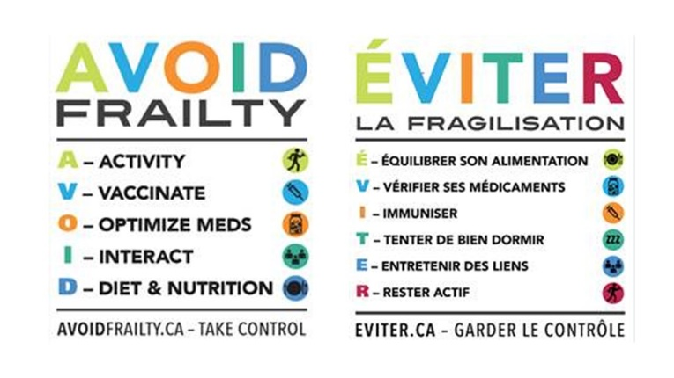
AVOID Frailty Program Overview
Driven by a holistic view of health, the AVOID Frailty Program for Healthy Aging provides the knowledge, tools, support, and opportunities to prevent, mitigate and/or delay the onset or worsening of frailty. Together with diverse partner organizations within the KFLA region, the KFLA Centre for Healthy Aging aims to harness and enrich communities with opportunities for ongoing age-friendly research, knowledge translation, and implementation of innovation. Using an approach that incorporates both a digital platform and personnel support, behaviour change strategies (i.e., education, self-monitoring, signposting, and nudging), the KFLA Centre facilitates individual-level and community-level adoption of evidence-based behaviours of healthy aging (healthyagingcentres.ca). For additional information on specific aspects of the KFLA Centre for Healthy Aging click here.

Competition Details
The maximum length of funding term is 18 months. A total maximum competition budget of $400,000 is available for this RFP and the single proposal budget maximum is $75,000. All questions submitted to CFN regarding this competition will be answered and posted online. To access FAQs click here.
While any area of study concerning healthy aging is eligible, studies that focus on one of the following priority areas and are synergistic with the AVOID Frailty framework (including sleep and/or falls prevention) will be viewed more favourably:

- Social determinants of health and wellbeing for older adults – Older adults are not a homogeneous group with respect to considerations such as: age, gender, income level, culture/ethnicity, education, etc. Studies that study one or more of these factors as a primary focus for differential health or frailty outcomes are sought.

- Biological and/or physiological determinants of health and well-being of older adults – CFN will be capturing self-reported and performance-based measures of health and frailty in KFLA Centre for Healthy Aging participants. We are interested in funding studies that enhance our ability to track and predict participant outcomes, by measuring diagnostic or prognostic biomarkers (e.g., blood biomarker analysis) to indicate health status or frailty progression in participants.

- Innovation in technology-enabled healthy aging and assessment – CFN is looking to fund studies that make use of innovative technologies (e.g., wearables) to enable, track and/or study healthy aging in KFLA Centre for Healthy Aging participants. We have developed a web-based technology platform to deliver and study the AVOID Frailty intervention via the KFLA Centre for Healthy Aging. CFN is interested in supporting studies that further the knowledge base around the potential of technology to foster enhanced evaluation and implementation of AVOID Frailty interventions towards healthy aging.

Although not required, a proposal will be more competitive for funding if it includes partners who have committed cash or eligible in-kind contributions. There is no minimum partner contribution requirement although higher cash and in-kind partner funding will be weighted higher in proposal evaluations.

Proposals must:
- Utilize the existing technological, participant, and virtual infrastructure of the KFLA Centre for Healthy Aging. For additional information on specific aspects of the KFLA Centre for Healthy Aging click here.
- Project teams must be willing to collaborate with CFN and its partners for study co-design if necessary.
- Study frailty or healthy ageing as a means of frailty prevention.
- Have a clearly stated hypothesis, rationale, goals, and objectives, with clearly defined milestones and deliverables.
- Include an evaluation plan (qualitative and/or quantitative).
- Demonstrate project feasibility through a detailed description of the methodology and by the inclusion of experienced team members, partners and collaborators with the appropriate expertise.
- Have at least one Principal Investigator (PI) from or affiliated with a Tri-Council eligible host institution located in the KFLA region.
- Include Highly Qualified Personnel (HQP) trainees who will be directly involved in a meaningful way in the study. HQP can be part-time or full-time graduate/doctoral/post-doctoral or undergraduate students, residents, fellows or working professionals. Note that meaningful involvement in the study components of a project includes activities such as data collection, data synthesis, report writing, etc., but would exclude tasks that are more related to administration and/or coordination (e.g., data entry, meeting scheduling, minute taking, completion and distribution of paperwork, etc.).

How To Apply
The application process requires submission of a Letter of Intent (LOI) prior to submitting a Full Application. CFN will only accept a Full Application if a LOI has been submitted by the deadline.
Step #1 – Letter of Intent (LOI):
- Go to CFN’s Forum website to complete the online LOI by clicking here.
- Information collected in the LOI will include; study summary (rationale, hypothesis, objectives, milestones, deliverables), team members and partners.
- The LOI is for administrative purposes only and will not be adjudicated.
- Project team member lists must include all confirmed and anticipated Principal Investigators (PI) and Co-Investigators (Co-I). No additional PIs or Co-Is can be added after the LOI has been submitted but PIs and Co-Is can be removed. The Project Leader (PL; i.e., primary lead PI) is responsible for managing the project team and reporting project progress and final results. The PL is the primary contact for CFN.
- After registering your LOI, you will receive a CFN file number that you will use to submit your completed online Full Application.

Step #2 – Full Application: Only Project Leaders that have previously submitted an LOI are eligible to submit a Full Application. Go to CFN’s Forum website (click here) to complete the online Full Application, which will be available after the LOI deadline. Note: A PDF of the Application for information purposes will be available on CFN’s website soon after launch. Please review the Application Instructions document prior to completing the Full Application. A Full Application is comprised of:
- Application Form (Captures admin information, project description, budget justification and team and partner details)
- Partner List/Partner Letter(s) of Support
- Project Team Information
- Budget
- Principal and Co-Investigators’ CIHR biosketch CVs
- CVs of other team members
- Required signatures
- Proof of study submission to Research Ethics Board (REB) – CFN is requiring that all applicants demonstrate that they have submitted their study for REB approval. For applicants whose REB will not review studies prior to funding, please provide a letter from your REB stating that reviews will only take place once CFN funding is confirmed. Note that successful applicants will need to submit REB approvals to CFN before funds can be forwarded to the eligible institution.

Important Dates
Please read Program Guidelines and the Application Instructions carefully before completing and submitting your LOI and Full Application.
- Competition launch: September 6, 2022
- Deadline to Submit LOI: October 3, 2022 - 4 pm ET
- Deadline to Submit Full Application: November 7, 2022 - 4 pm ET
- Adjudication of Full Applications is estimated be completed by late December 2022.
- Successful Applicants should be notified in early January 2023. Funding will commence after all necessary agreements have been executed and REB approval(s) received.

Specific deliverables required by CFN
- Progress reports every six months updating CFN on latest activities, preliminary findings etc.
- A final detailed report at project end date.
- A face-to-face or online meeting at project end date to discuss final results/findings.

Evaluation Criteria
The mechanism of proposal evaluations will involve the creation of an evaluation rubric that will encompass how well the application addresses the above requirements. Only proposals with a Project Leader (i.e., the Principal Investigator) from an eligible host institution within the KFLA region will be evaluated. Budget expenses and contributions must adhere to Tri-Council Guidelines.

Terms and Conditions
By submitting a proposal, the applicant/organization acknowledges and agrees that CFN has no liability or obligation to any applicant/organization, except to the party (or parties) that is awarded the contract by CFN in its sole discretion. CFN shall be fully and forever released and discharged of all liability and obligations in connection with this grant. CFN reserves the right to cancel this grant at any time without any obligation or reimbursement to organizations.

Contact for Further Information
Perry Kim, PhD, Assistant Scientific Director
Email: research@CFN-nce.ca

