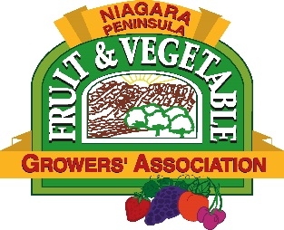
NIAGARA PENINSULA FRUIT AND VEGETABLE GROWERS ASSOCIATION
Summary of Project & Goals Outline

The total proposal should not exceed 7 pages including this Summary.
Those receiving funding will be expected to attend an annual meeting to share project outcomes and preliminary results if asked. A final project report will be requested for distribution to the NPF&VGA membership and grower community.

Please email (preferred) or mail completed forms to:
NPF&VGA
c/o Kelle Neufeld
PO Box 100
Vineland Station, ON
L0R 2E0
E-mail: npfvga+research@gmail.com

Project Title
Researcher’s Name, Affiliation
Project Description
Overall Research Objectives
Relevance to Industry Priorities
Project Start Date
Project End Date
Total Project Budget
Funds Requested from NPF&VGA
Sources of Matching Funding (if applicable)

NIAGARA PENINSULA FRUIT AND VEGETABLE GROWERS ASSOCIATION
Standard Application Form

The total proposal should not exceed 7 pages including the Summary.
Those receiving funding will be expected to attend an annual meeting to share project outcomes and preliminary results if asked. A final project report will be requested for distribution to the NPF&VGA membership and grower community.

Please email (preferred) or mail completed forms to:
NPF&VGA
c/o Kelle Neufeld
PO Box 100
Vineland Station, ON
L0R 2E0
E-mail: npfvga+research@gmail.com

Project Title
Researcher’s Name and Affiliation
Mailing Address
Telephone
Email
Website
Project Start Date
Project End Date
Project Description
Overall Research Objectives
Scientific approach/methodology (including experimental design)
Rationale & Relevance (Benefits) to the Ontario fruit & vegetable industry
Where the research will be conducted (facilities available, etc.)
Communication Plan
Total Project Budget (attach as separate pg)
Funds Requested from NPF&VGA
Sources of Matching Funding
Please include a brief CV (last 3 years)

ATTACH ADDITIONAL PAGES IF NECESSARY.

