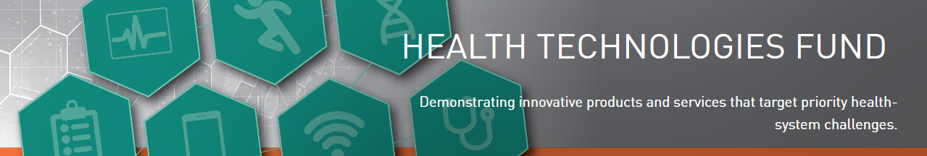
Expression of Interest (EOI) Template

IMPORTANT PROJECT INFORMATION:
- Commitment letter required by the Health Service Provider (HSP) lead for all types of HTF projects. Letter should outline level of commitment (Cash and/or in-kind), types of activities to support and rationale why this proposed project is a priority.
- Applicants are encouraged to gain a letter of endorsement from their respective LHIN
Project Profile
Provide the Project Type (Pre-market Evaluation, Early Adoption)
Provide the Health Priority area selected
Number of Demonstration Sites
Provide the Name and Location of the Demonstration Site(s)
Summary of Proposal for Public Release
Provide a plain-language summary of the overall objective of the project. This summary will be used for communications materials should the project be approved for funding. (max 50 words).
1: Problem Statement and Proposed solution (MaxiMum 1 page)
- In alignment with the selected health priority area, provide a “Problem Statement” that outlines the challenge you aim to address. The Problem Statement should articulate the challenges and opportunities for which a solution could have substantial system impact.
- What is the innovative technology, product or process that will be demonstrated? Provide a schematic to support the description. Indicate to what extent the solution has been validated (e.g. regulatory certifications). Provide specific examples of how the innovation addresses the elements of the Problem Statement.
- Problem Statement: (Type Here)
- The Solution: (Type Here)

2: Project Objective and Collaboration (Maximum 1 page)
- State the overall goal to be achieved in the proposed project. Provide the key project activities required to achieve the project outcomes in the Milestones Table below.

- Describe the collaborations within the Health Innovation Team (HIT) that will take place to achieve the objectives of the project. Include the roles and responsibilities of the HIT members (include name, title, organization and project role/responsibilities).
  - HITs should include, but not limited to assignment of the following responsibilities: Project management, change management, workflow management, data collection/analysis, patient engagement and adoption and procurement, evaluation.
  - For key team members, briefly describe their track record of engagement with other knowledge users, including government (i.e., policy makers, health care leaders, and providers).
  - Patient engagement in the design, delivery and evaluation is required and will be significant to the success of the project. Ensure that patient engagement is reflected in the team and project activities.
- State the Overall Goal the proposed project:

Milestone Table
Please list the key milestones in the table below (add more lines as necessary)
Activity | Team Member | Expected Outcome | Duration  (e.g. # months)
(Type any additional information here)

- (Type Here)

3: IMPACT (Maximum 1 page)
- What will be measured to support achieving the overall goal of this initiative?
- Who is the evaluation partner and describe how they will support any evaluative efforts related to the project objective including overall impact against the following:
- Health care system performance (e.g., redesigning of the health care system, health outcomes, patient experience, health system costs, etc.);
- Existing and future infrastructure (e.g., supply chain, IT support, etc.);
- Policy (e.g., reimbursement models, scope of practice constraints/opportunities, regulatory/legislative policy, etc.);
- Economic development within Ontario (e.g., globally competitive business and market opportunity, etc.);
- Industry;
- Practitioners; and
- Patients.
- (Type Here)
- (Type Here)

4: Adoption and Scalability (Maximum 1 page)
- What are the potential barriers to adoption for your proposed solution? (Examples include: The processes that will be used to buy the solution, behavior change of users such as clinicians or patients, workflow changes at the health service providing organization)
- How will you address these barriers within your project and how will the project outputs support wider adoption and/or scalability?
- (Type Here)
- (Type Here)

