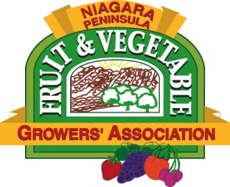

NIAGARA PENINSULA FRUIT AND VEGETABLE GROWERS ASSOCIATION
Standard Research Proposal Form

The total proposal should not exceed 6 pages.
Those receiving funding will be expected to attend an annual meeting to share project outcomes and preliminary results. A final project report will be requested to distribute the results to the NPF&VGA membership and grower community

Please email (preferred) or mail completed forms to:
NPF&VGA
c/o Mary Pawlus
P.O. Box 145
St. Davids, Ontario L0S 1P0
Tel: 289-477-1051
E-mail: mpawlus@cogeco.ca

Project Title
Researcher’s Name, Affiliation, and Mailing Address
Telephone
Fax
Email
Website
Overall Research Objectives
Project Description

Scientific approach/methodology (including experimental design)

Communication Plan
Project Start Date
Project End Date
Rationale & Relevance (Benefits) to the Ontario grape and tender fruit industry

Facilities available to conduct research
Where the research will be conducted
Estimated Total Project Budget
Funds Requested from NPF&VGA
Sources of Matching Funding

Please include a brief CV (last 3 years)

Revised 09/14

