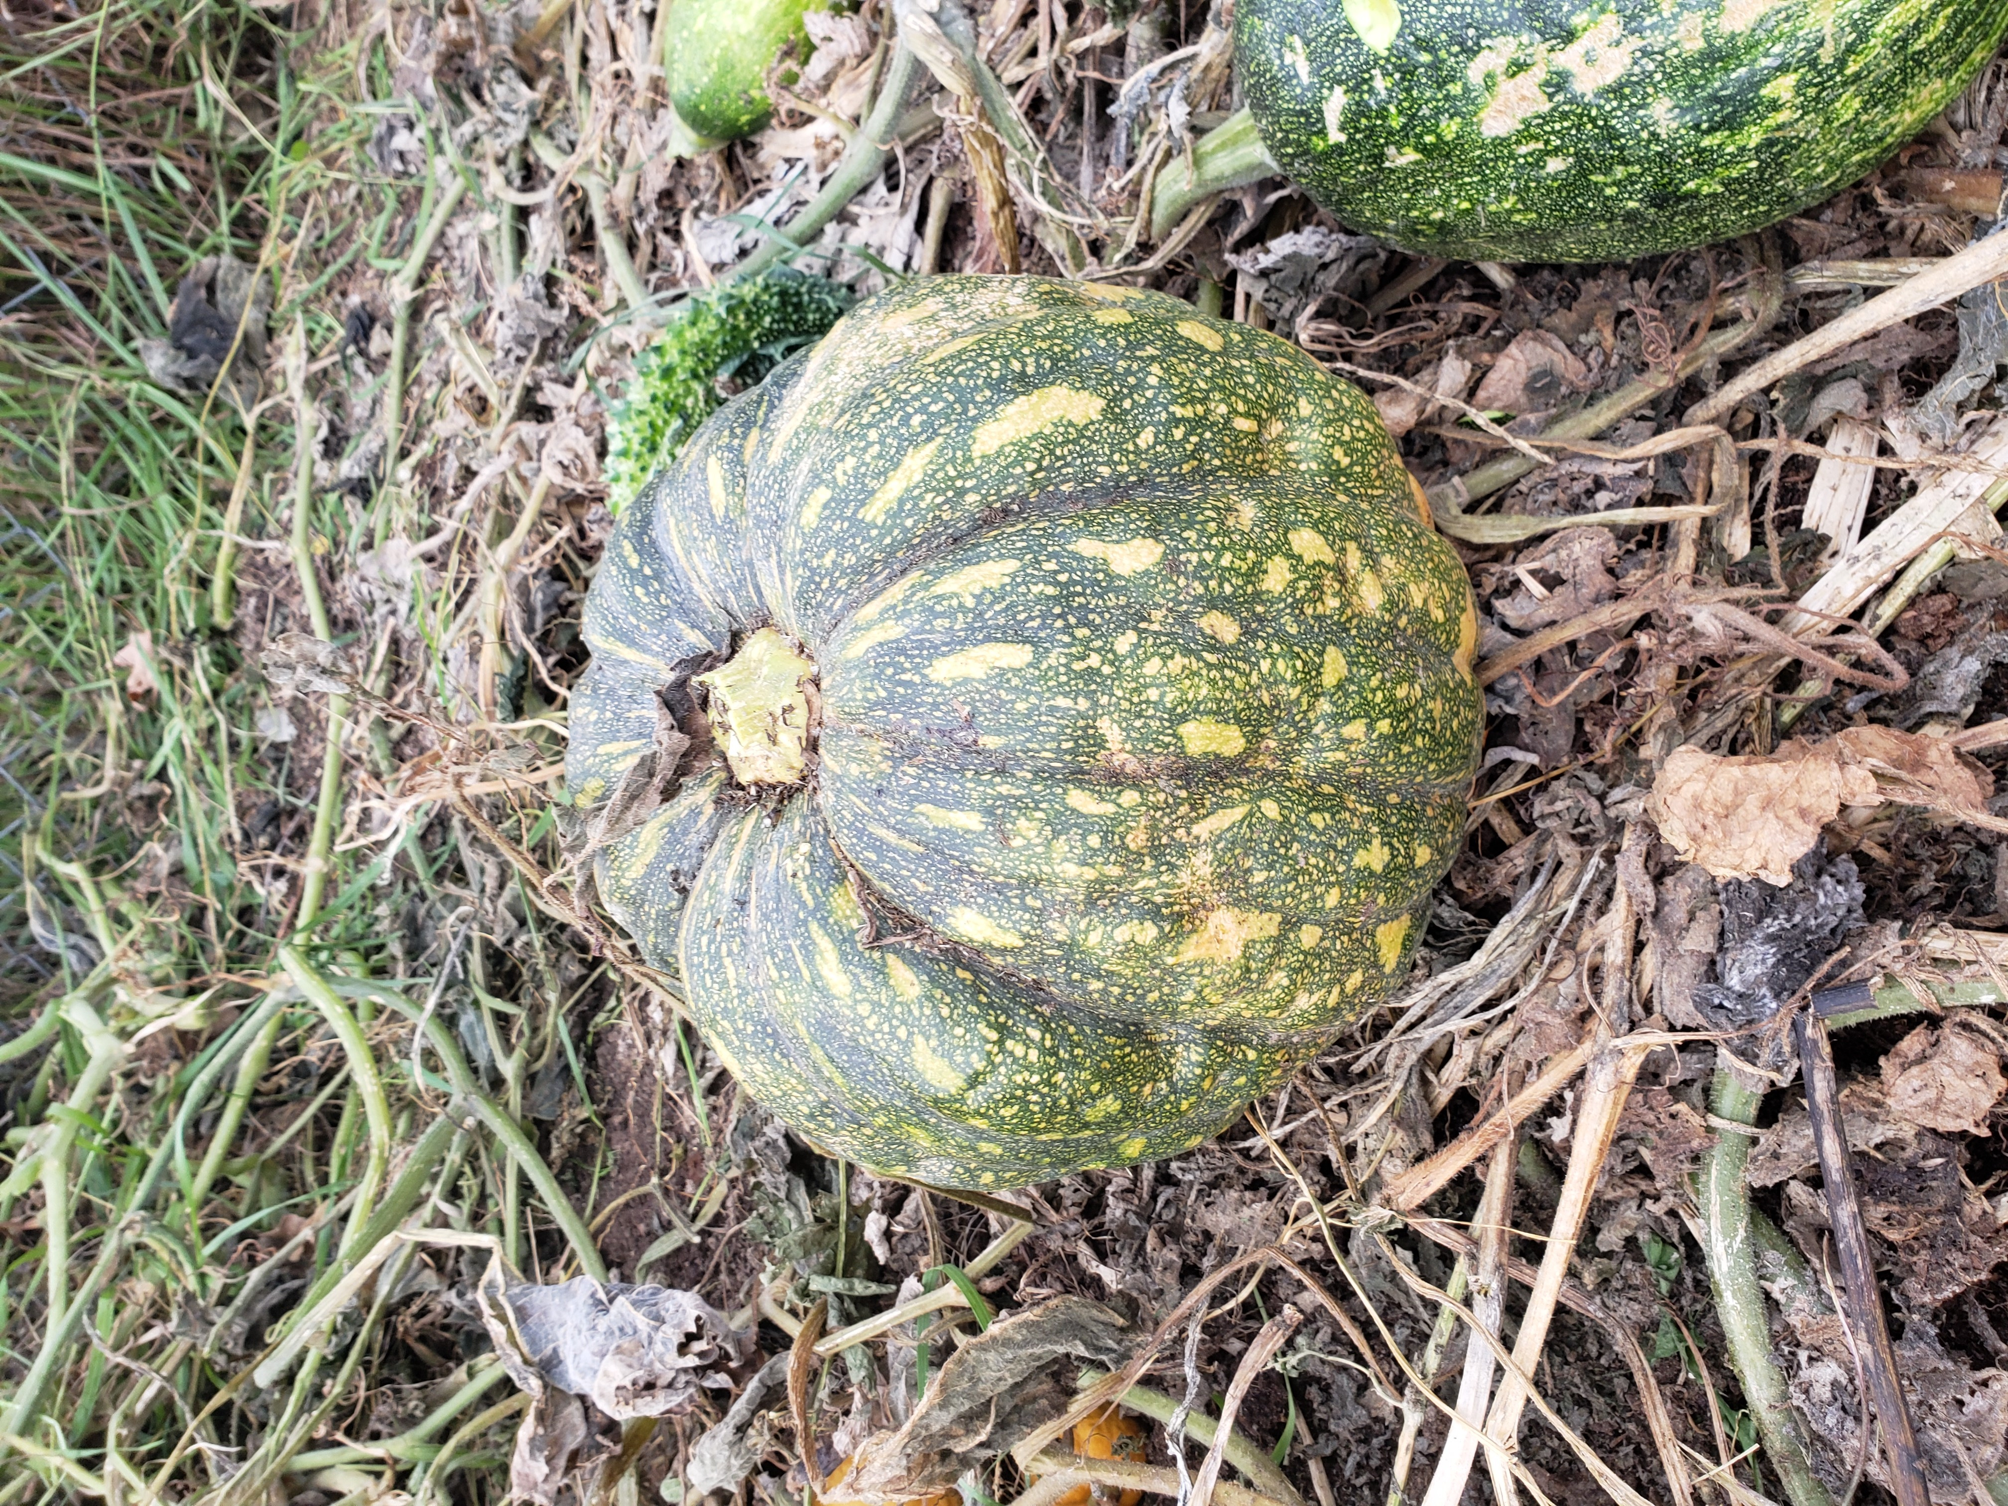  united way  Guess the weight to win!  United Way Ayote Squash Auction  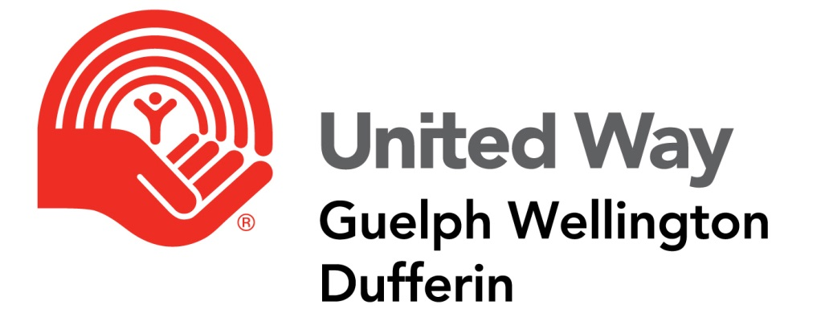  Each guess is a dollar. Write your contact information on the provided slip and place a dollar (or more!) in the box for our PR United Way Campaign! | Guess the weight of the Ayote Squash!  Located at Reception in Hersey Building  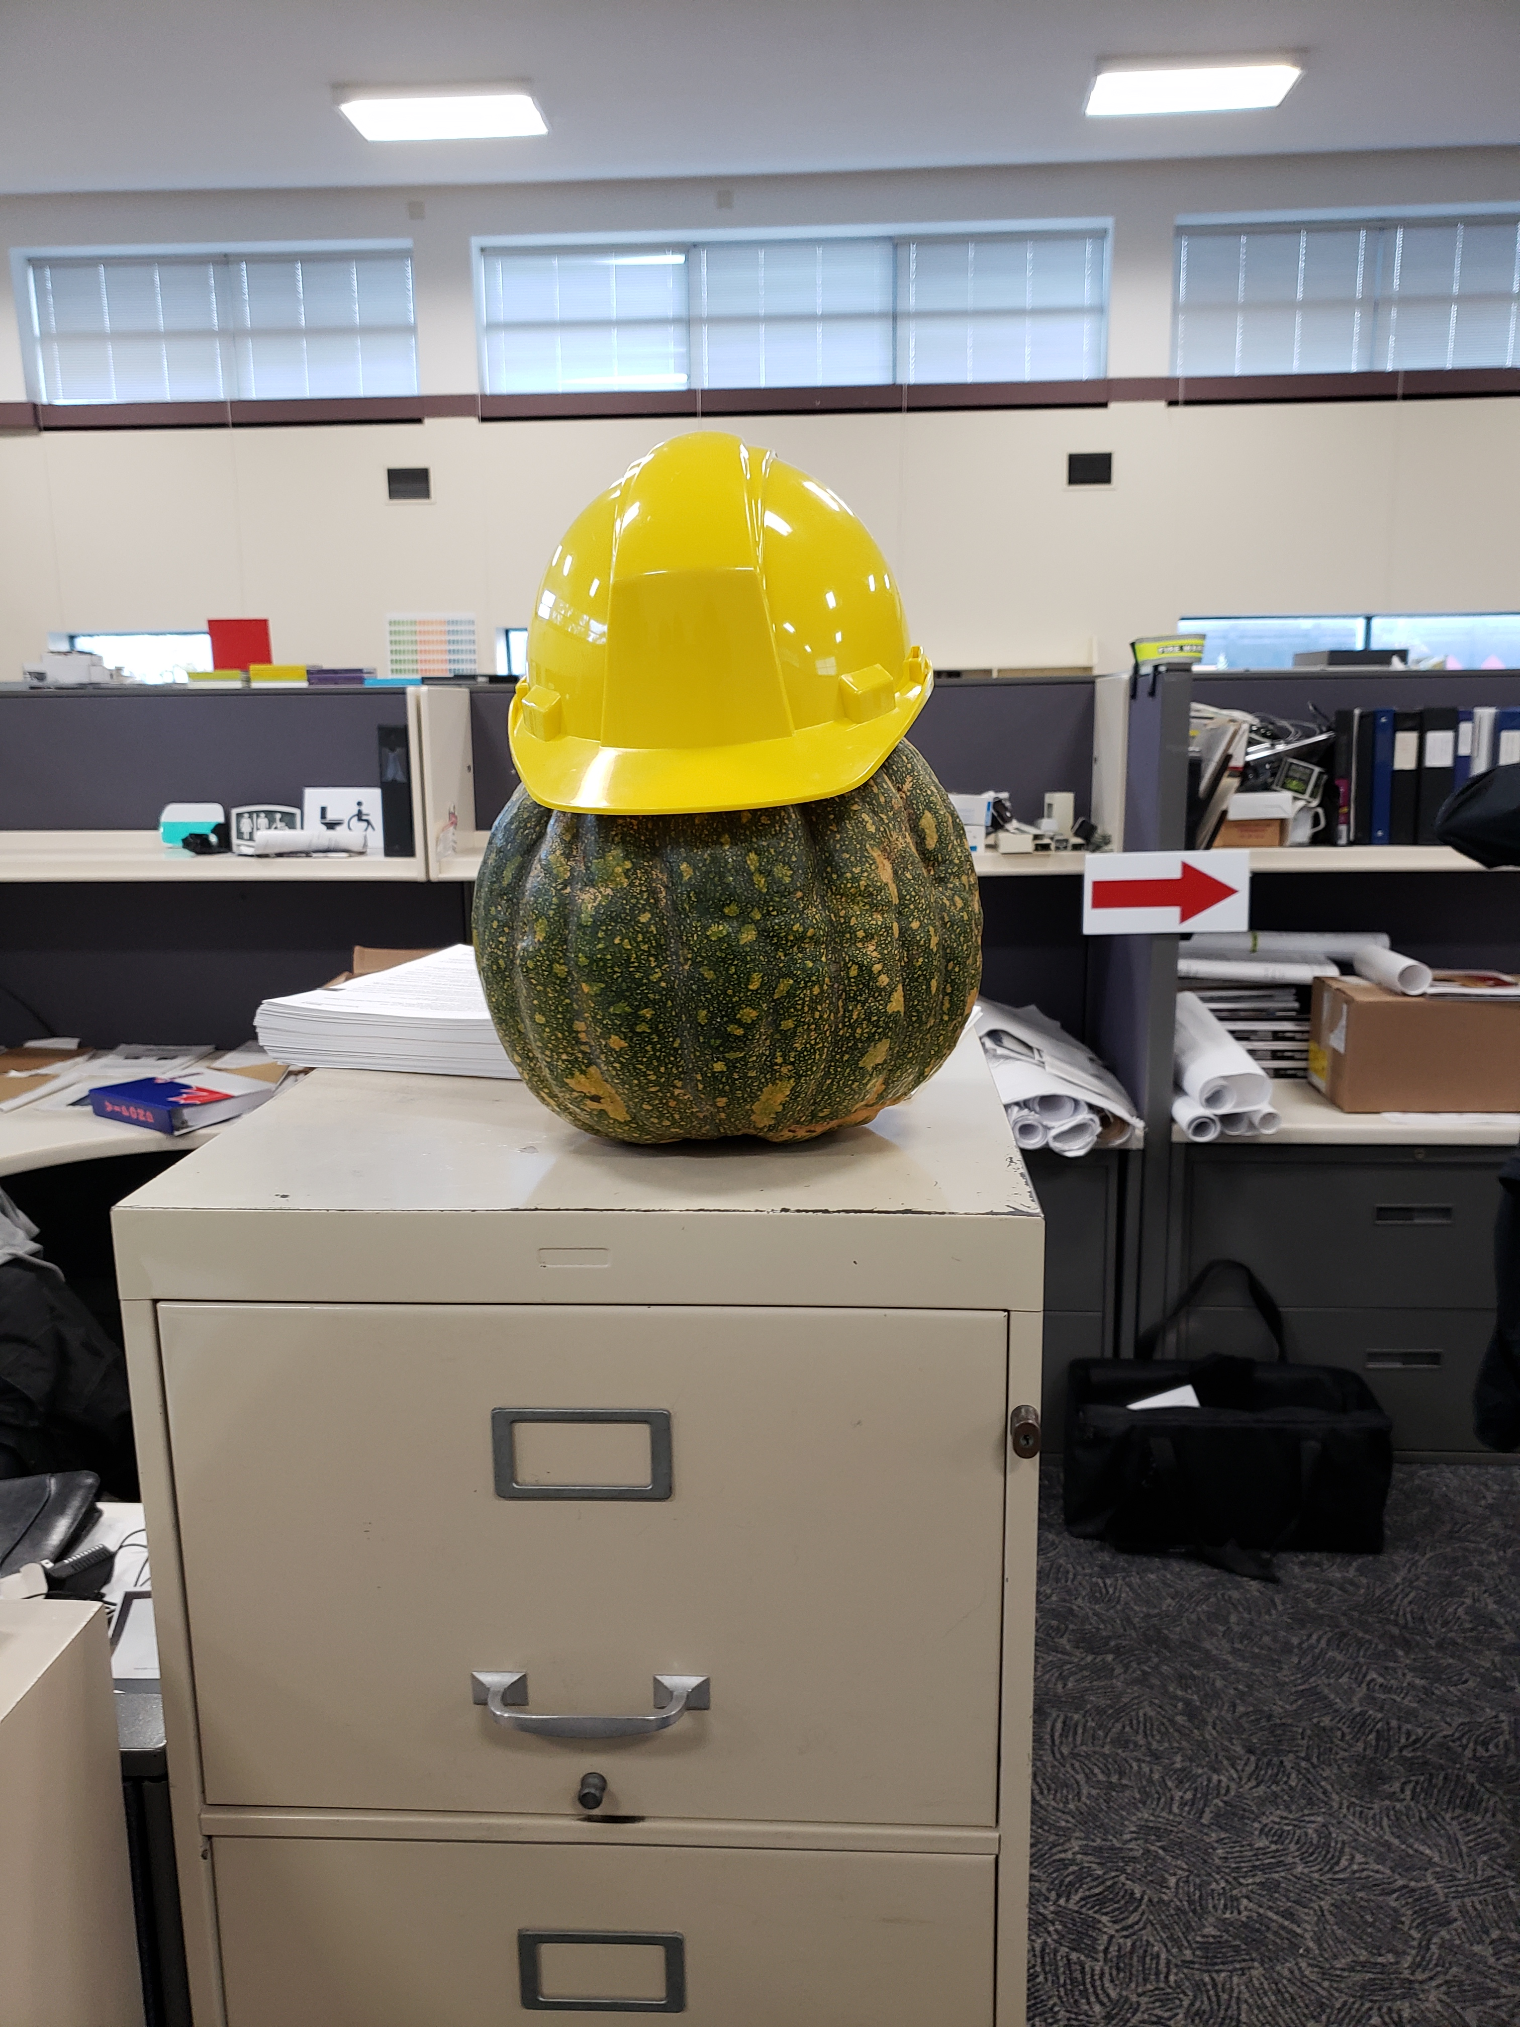  Just $1 a guess! All proceeds go directly to United Way!  Draw on Nov 2!  Located at Hersey Building  Near Reception

