
Tickets: 4 for $10.00
Can be purchased at Drew Hall from 8:30 – 4:00 any day
Wednesday Nov. 7 at Creelman (11:30 – 1:00)
Thursday Nov. 8 at OVC (all day)
Friday Nov. 9 UC Courtyard 10am – 3pm
Monday to Friday, November 12-16 at Events Room, UC 432
Draw to be held November 23, 2018
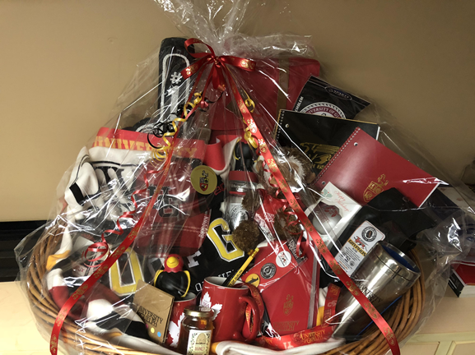
Maple Lodge Farms Collection: approx. value $150.00 Gryphon Basket: approx. value $380.00
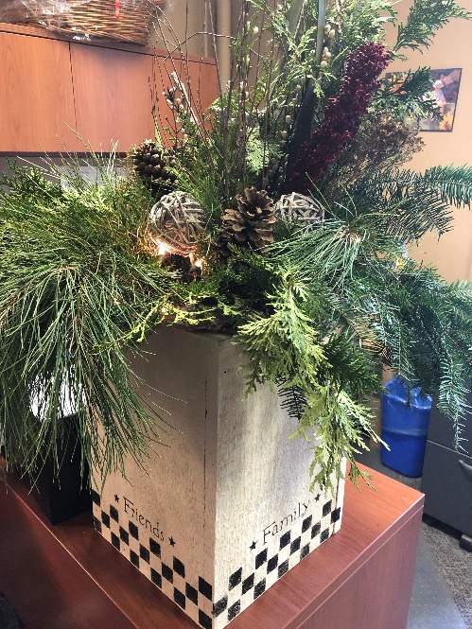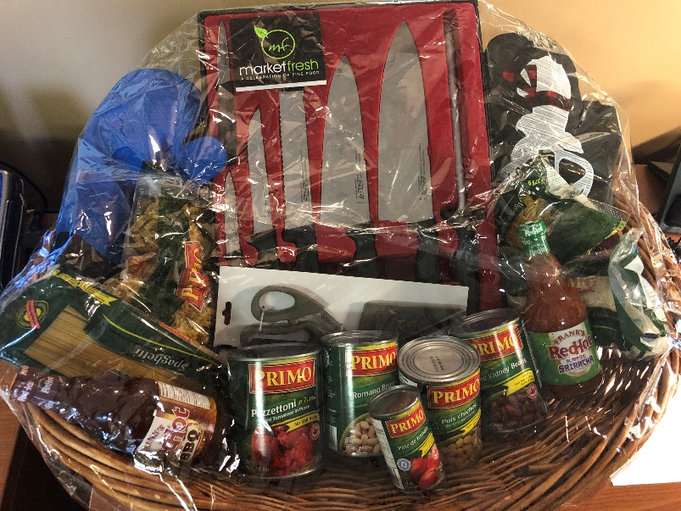
Hand painted Winter Box approx. value: $100 Kitchen Basket: approx. value: $250.00

