Bake Sale & Raffle Table
In support of United Way
Treasury Operations – Financial Services
4th Floor University Centre

Thursday November 15th, 2018

Drop by during the day to check it out and buy tickets!

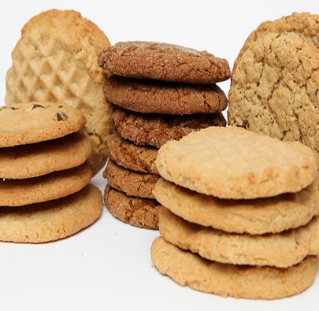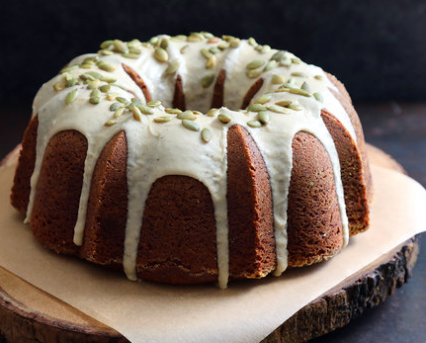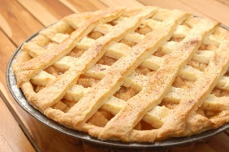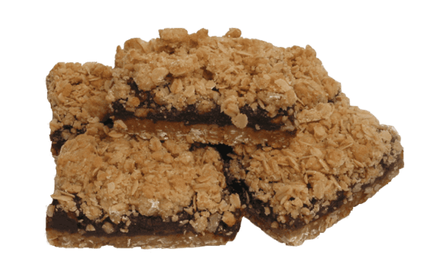

Raffle tickets $2 or 3 for $5
Available at Treasury Operations (4th floor UC)

Draw to be held at 3:00 pm
Front Counter, Treasury Operations

