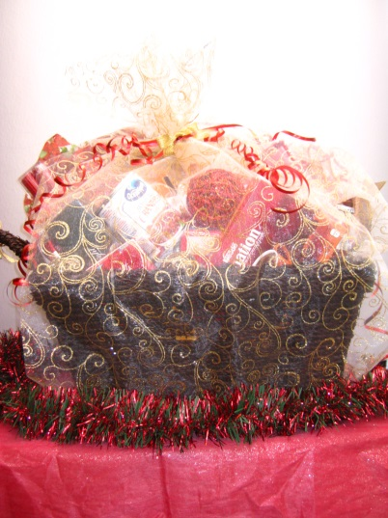  #1 Christmas Dinner (Admin/Facility/OAHN)  Table cloth  Napkins  Decorative balls  Candles  1 mickey of Gin – Beefeater  6 bottles of Sleeman’s Cream Ale beer  Sparkling water  Salad dressing  Squash soup  $25 butterball turkey voucher  Stuffing  Cranberries  Artichoke spinach rice  Carrot cake mix  1 container whipped cream cheese icing  Tim Horton coffee  Hot chocolate pouches  Hot chocolate candy accessories  After dinner mints | 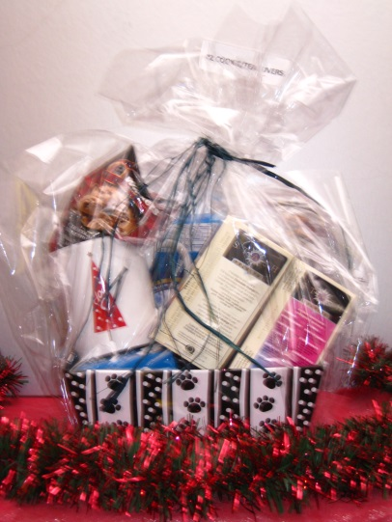  #2 Cookie/Tea Lovers  Mug  Chocolate chip short breads  Organic chocolate orange tea  Box of assorted teas  Tea biscuits  Shortbreads  Butter cookies  Relaxing David’s teas |  | 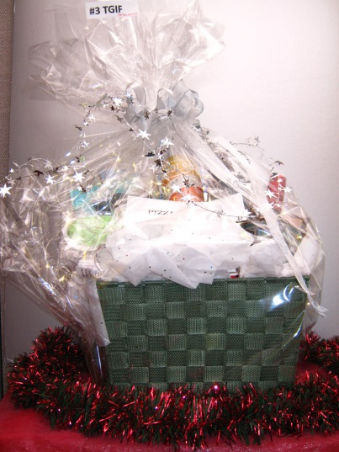  #3 TGIF  $25 gift card to Amazon  $ pizza voucher  Decorative green woven fabric basket  Large box of assorted cookies  Tazo awake tea  Cappuccino chocolates  Coffee mug  Waterloo dark beer  Three Speed lager  Richard Radler grapefruit flavoured light beer  Sleep mask  Wine glass  Mont Pulciano d’Abruzzo red wine  Timothy’s mild Christmas blend coffee  Chicago mix  Toasted coconut hard toffee with sea salt
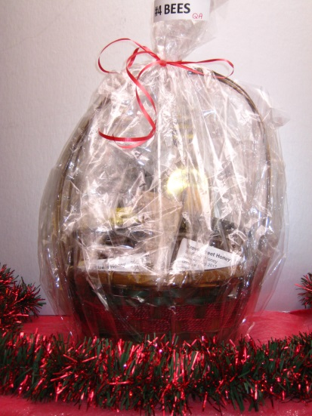  #4 Bees (QA)  2 kg of wildflower honey harvested Aug 2017, Ontario #1, single source  2 bottles of wine (1 red, 1 white) by Twenty Bees  Votive beeswax candle  Decorative basket | 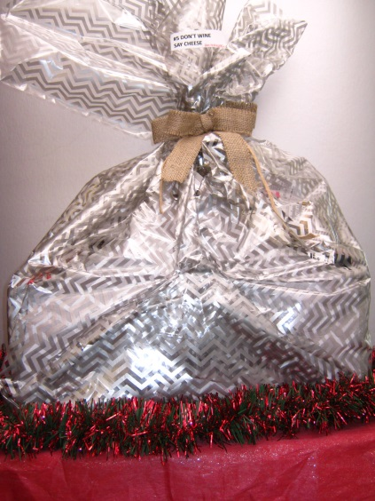  #5 Don’t Wine, say Cheese (Bacti)  $25 gift certificate to Paola’s Fine Cheeses  Thirty-one basket  blanket  2 bottles of wine  charcuterie board  jellies/dips  cheese knife set  napkins  wooden serving utensils | 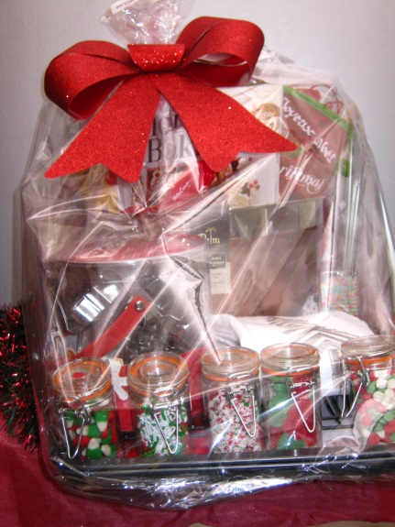  #6 Christmas Baking (Viro)  $10 starbucks gift card  5 jars of decorative candy sprinkles  Dessert decorator  2 tea towels  2 baking trays & 2 cooling racks  18 cookie cutters  Large metal mixing bowl  Measuring cups & Measuring spoons  Paper muffing wrappers/cups  Canadian Living holiday baking recipe book  Cooking mitts  1 spatula  1 flipper  Whisk  Wooden rolling pin  Wooden spoon  Apron  Parchment paper  2 large serving plates  Candy bags
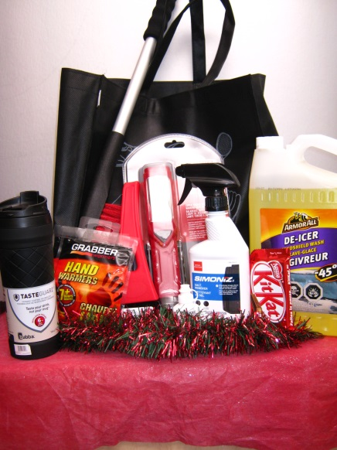  #7 Winter Car Kit (Toxi, Soil & Nutrient)  De-icer windshield wash  Lock de-icer  Salt remover  Super-bright work light  Large window scraper/brush  Small window scraper  2 hand warmers  Insulated rubber coated ceramic travel mug  1 bag Werther’s caramel hard candies  4 chocolate bars  Cloth shopping bag | 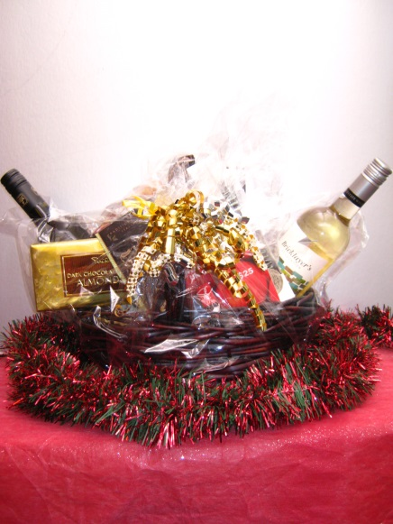  #8 Wine and Chocolate (Clin Path)  $25 PC gift card  Canadian Gothic red wine  Bricklayers Foundation white wine  Melting parmesan cheese sticks  Large PC dark chocolate almond bar  Traditional Artisanal style Italian cookies  Cadbury milk chocolate fingers  Walker’s mint chocolates  Decorative basket | 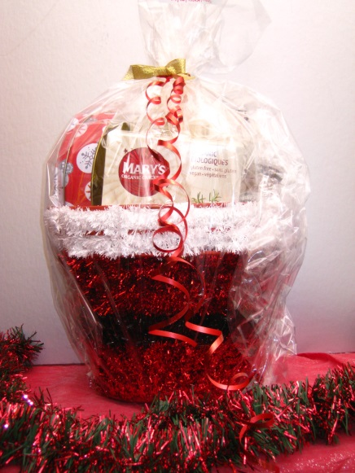  #9 Date Night-In (Myco/Para/Molecular)  Irish whiskey from Ireland  Fancy gluten free crackers  Jam  Homemade shortbread cookies  Green tea  Movie: The kids are all right  Decorative basket/bucket

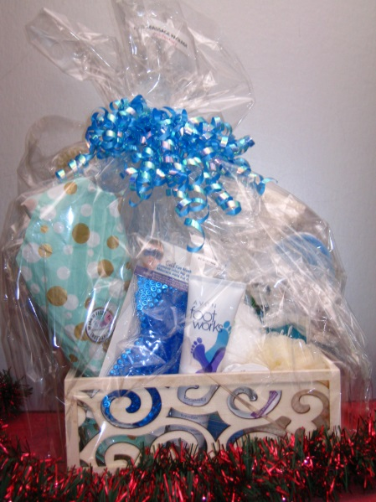  #10 Massage Package (Histo)  1 gift certificate for massage at Balance Integrated Health Solutions  Avon foot cream  Gel eye mask  Eucalyptus Epsom salts  Make it Fizz bath bomb  Scrubby  Scrubby glove  Pumice stone  Loofah sponge  Scrub brush  Bath and Bodyworks shower gel  Bath and Bodyworks body cream  Slippers  Decorative wooden box | 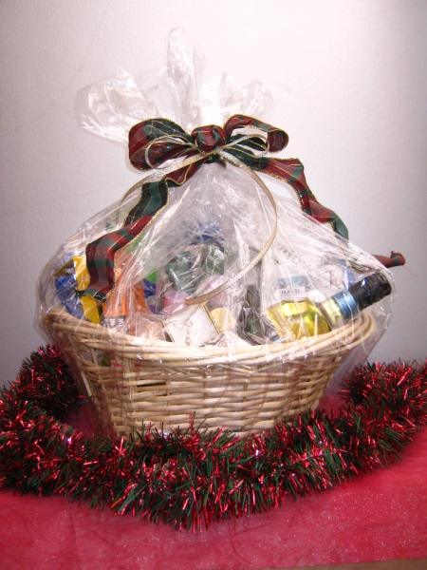  #11 Slow down and Relax (Specimen Reception)  $20 LCBO gift certificate  bottle of wine  Nora Roberts book  To Bathe: lotion & soap  Bath & Body cream  Creme from Holland  Assorted travel shampoo's, conditioners & soaps YoYo Colouring pens Toothbrushes  Decorative basket | 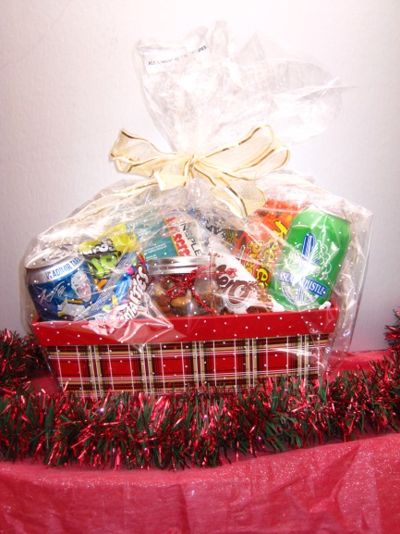  #12 Night at the Movies (Post Mortem)  Cineplex movie passes  1 bottle Creemore Spring Ale  1 can of Steam Whistle beer  Fruitopia lime twist  1 jar of mixed nuts  Aero bar  Reese pieces  Smarties  Sour patch kids  Microwave popcorn  Mike & Ike mix  Decorative box

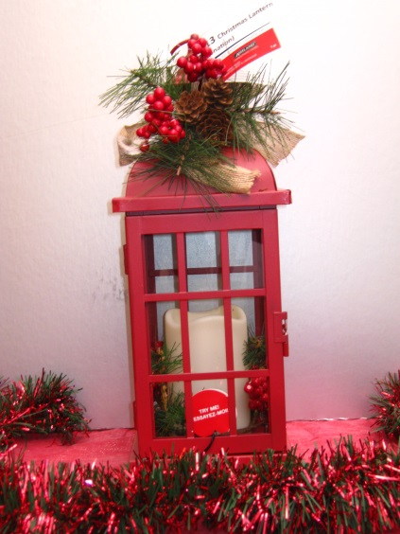  #13 Christmas Lantern | 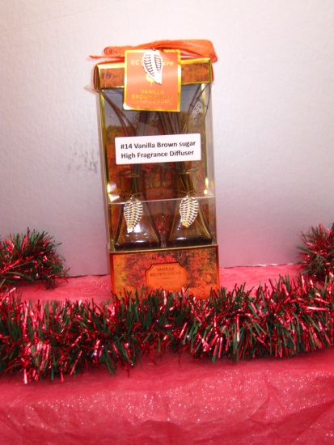  #14 Vanilla Brown Sugar High  Fragrance Diffuser | 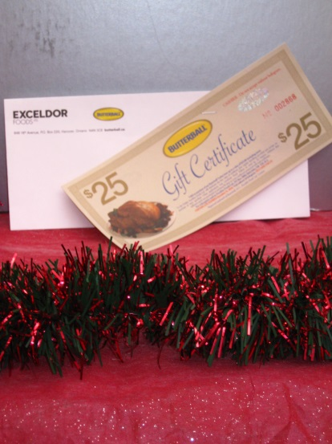  #15 $25.00 Butterball Turkey Gift Certificate

