Hospitality Services, Drew Hall
United Way Basket Raffle
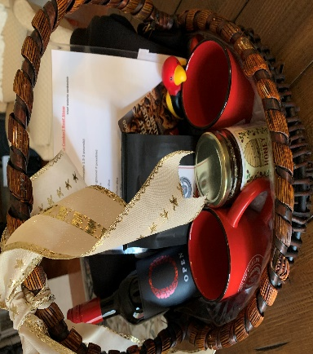

3 tickets for $5.00
5 tickets for $10.00
Basket’s approximate value: $200.00
Includes:
Black University of Guelph Hoodie
2 University of Guelph Mugs
1 bag University of Guelph Coffee Beans
1 jar University of Guelph Honey
Portable Hand Sanitizer
Stress Gryphon
1 bottle Open VQA Smooth Red Wine
$50 Zehrs Gift Card
Slow Cooker Beef Stew Recipe from our very own Chef Val Jankovich

Name: _________________________ Ticket Purchase:
Email: __________________________ $5.00 for 3 Tickets: _______________
Phone: _________________________ $10.00 for 5 Tickets: ______________

Please email form and e-transfer money to rruda@uoguelph.ca
Draw will be made December 1, 2020 and winner can pick up the basket at the University Bookstore

